091205T4PTT
PERIOPERATIVE THEATRE TECHNOLOGY LEVEL 5
HE/OS/TT/CR/01/5/A
EXECUTE PERIOPERATIVE SAFETY PRECAUTIONS
Nov. /Dec. 2022

THE KENYA NATIONAL EXAMINATIONS COUNCIL

WRITTEN ASSESSMENT
Time: 3 hours

INSTRUCTIONS TO CANDIDATES
Maximum marks for each question are indicated in brackets ( ).
This paper consists of THREE sections: A, B and C.
Answer questions as per instructions in each section.
You are provided with a separate answer booklet.

This paper consists of EIGHT (8) printed pages
Candidates should check the question paper to ascertain that all pages are printed as indicated and that no questions are missing

SECTION A: (20 MARKS)
Answer all question in this section
Each question is 1 mark
The diagram below indicates a perioperative theatre environment; use it to answer questions 1-2
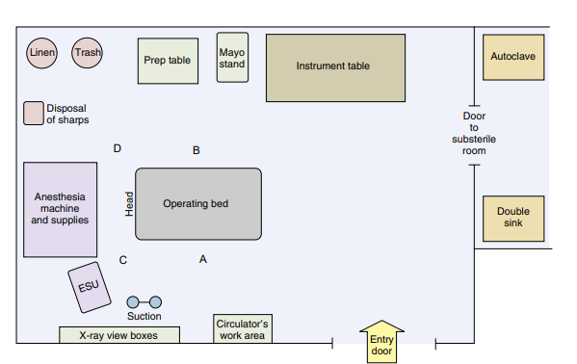
- What is the ideal theatre staff to occupy position labeled A?
- Surgeon
- Anesthetist
- Scrub person
- Circulating nurse
- Where would you place instruments urgently and frequently used during surgery
- Prep table
- Operating bed
- Instrument table
- Mayo stands
- The most important things that you would use during the positioning of a surgical patient on the operating table is/are:
- Positioners and strappings
- A Trolley
- A Cooperative patient
- A Mask
- How many times should you count the abdominal swabs after the surgeon makes first incision during a caesarean section?
  - Three
  - Two
  - Five
  - Four
- How many times should you count the surgical instruments in a perioperative theatre?
- Four
- Three
- Two
- Five
- Which of the following personal protective equipment would you remove first after surgery?
  - Face mask
  - Surgical gloves
  - surgical Gown
  - Head cap
- During waste disposal, general waste is put into?
  - Containers lined with black bags.
  - Containers lined with clear bags.
  - Sharps containers.
  - Containers lined with yellow bags
- The anatomical waste consists of human and animal tissue, organs, and body parts should be disposed to which containers during waste segregation?
  - Containers lined with red bags.
  - Sharps containers.
  - Containers lined with yellow bags.
  - Containers lined with black bags.

- The PPE recommended for surgery anticipating ionizing radiations is:
- Theatre scrubs
- Surgical gloves
- Face shields
- Lead gloves
- Which of the following is true about positioning patients in operation table?
- It is informed by patient’s preference
- Appropriate table accessories should be used
- It is not informed by the procedure to be done
- It should be done by one person only
- The best way of disposing sharps in the operating theatre is?
- Capping all needles before place on sharps container
- Throwing all used surgical blades in red coded bin
- All needles should be placed in tamper proof safety box
- Syringes and needles should have disposed separately
- Which of the following is a reportable sentinel event in theatre?
- A retained foreign object from surgery
- Any near miss
- Any sentinel event that has not affected the recipient of care
- Full return of limb or bodily function by discharge or within 2 weeks of the initial loss of function
- Care of the operating table involves?
- Daily oiling of the movable parts
- Canalizing after every patient encounter
- Regular painting
- Positioning the patient on operating table
- Which of the following procedures requires use of a sterile glove?
- Receiving a patient in theatre
- Catheter insertion
- Physical examination
- Abdominal examination
- Which one of the following is an Operation safety measure in an operating theatre?
- Fire extinguishers
- Use of anesthesia
- Operating theatre
- Theatre ceiling
- A correct statement entailing patient identification would involve:
- “Are you Mr. X? I’m here to take you to surgery.”
- “Can you state your full name and date of birth for me?”
- “So, Dr. X is planning to operate on your arm today.”
- “Will you be having a laparotomy today?”
- When transporting a patient to the operating theatre: -
- Instruct the patient to open the doors in front
- Push the stretcher from the head
- Move rapidly to save on time
- Hang the fluid on a drip stand as you move the patient to avoid entangling of the tubing on wheels
- Why is skin prepping at the surgical site done?
- For inventory of the swabs purposes
- For the safety of the health personnel
- To ensure the patient is not smelling
- To ensure the site is free from microorganisms
- Patient positioning in operating table will best be determined by?
- The height of the surgeon
- Preference of the team
- Type and length of procedure
- Increased risk of tissue damage

- Draping of patients in theatre is done after: -
- Surgery
- Hand scrub
- Skin preparation
- Time out
SECTION B: (40 MARKS)
Attempt all questions in this section
- State five (5) factors that influence selection of Personal protective gears for use [5marks]
- Accountability is key for safe surgery, highlight four (4) items that you should count before starting an open surgery [4marks]
- While working as a perioperative theatre technician, Theatre alarms signals should be received and analyzed according to type and source of alarm. Identify four (4) sources of theatre alarm [4 marks]
- Counting and accountability of instruments is an important aspect of patient’s safety, state four (4) types of counts done in a perioperative theatre? [4marks]
- Explain the four main functions of perioperative theatre alarms [4 marks]
- Explain THREE (3) considerations to apply before transferring a patient to a trolley in theatre. [3 marks]
- Cases of wrong patients being taken for surgery has been on the rise, as perioperative theatre technician, state five patient identifiers? [5marks]
- Describe Five (5) actions you should take upon realizing a discrepancy during instrument counting in surgery? [5 marks]
- It’s important to check Completeness of theatre team before start of surgery, highlight four (4) members of sterile team with one role they perform in operation theatre [4 marks]
- Different devices are key in moving and transferring a patient in a hospital, list any four (4) moving and handling devices [2 marks]
SECTION C: (40 MARKS)
Attempt any two questions in this section
- Different surgical procedures require different surgical positions; describe ten (10) different surgical positions used in theatre [20 marks]
- While positioning a patient, you may need operating table attachments and accessories. The patient is positioned on the operating table for a specific surgical procedure:
- Explain three reasons for positioning surgical patients [6 marks]
- Describe eight (8) operating table attachments and accessories [14 marks]
- The purpose of a safety surgical checklist is to ensure safe surgery, explain the three parts components of a surgical theatre checklist. [20 marks]

