LEVEL 4

DEMONSTRATE NUMERACY SKILLS

Nov. /Dec. 2022

THE KENYA NATIONAL EXAMINATIONS COUNCIL

WRITTEN ASSESSMENT
Time: 2 hours

INSTRUCTIONS TO CANDIDATES
Maximum marks for each question are indicated in brackets ().
This paper consists of TWO sections: A and B.
Answer questions as per instructions in each section.
You are provided with a separate answer booklet.

SECTION A (10 MARKS)
(Answer all the questions in this section)
- State the number of cubic meters in 1000 litres of a liquid. (1 Mark)
  - 1 cubic meter
  - 10 cubic meters
  - 0.1 cubic meters
  - 1000 cubic meters
- Identify the most suitable unit used when measuring the volume of water in a cup.
(1 Mark)
  - m³
  - grams
  - ml
  - kg
- A customer wanted you to fabricate the following sheet metal in a workshop. Find the perimeter of the work piece. (1 Mark)
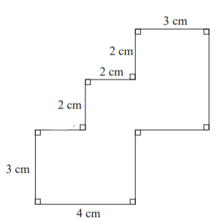
  - 24
  - 28
  - 26
  - 25

- Identify the largest fraction from the choices given. (1 Mark)
- $\frac{17}{20}$
- $\frac{7}{8}$
- $\frac{3}{4}$
- $\frac{6}{7}$
- In a workshop, Kerich requires 27 small pieces of steel tubing for a practical lesson. If each piece is $\frac{3}{4}$ inches long. Determine the length of the tube to be used to the nearest whole number. (1 Mark)
- 21 ft
- 20 ft
- 20 inches
- 21 inches
- In an engineering drawing lesson, one of the student got the following measurement as 23.4 centimetre. State the margin of the error of the measurement. (1 Mark)
- The measurement must be between 22.45cm and 24.45cm
- The measurement must be between 23.35cm and 23.45cm
- The measurement must be 23.45cm
- The measurement must be between 23.44cm and 23.46cm
- In a welding workshop 200 bushes are welded into a fixture. The instructions requires that the bushes should not have a defect rate of more than 2%. Find the percentage of defective pieces, if after recycling there are 3 defective pieces. (1 Mark)
- 3%
- 2%
- 5%
- 1.5%
- Two points A and B are indicated on a map. Identify a choice which is related to distance between them. (1 Mark)
- Title of the map
- Compass
- Scale
- Axis

- A steel support has four holes punched at equal distance from each other. Find the center -to- center distance between the holes. (1 Mark)
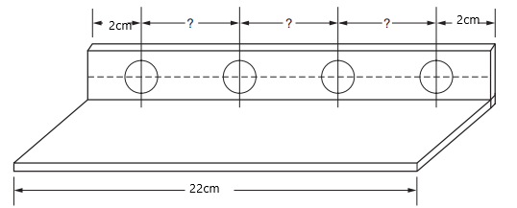
- 6cm
- 4cm
- 2cm
- 18cm
- The bar graph below indicates the number of blocks made by group of students in a week. The number of blocks made on Wednesday are 5 less than those made on Friday. If they made 304 blocks in total. Find the number of blocks made on Friday. (1 Mark)

  - 53
  - 48
  - 56
  - 54
SECTION B (40 MARKS)
(Answer all the questions in this section)
- Evaluate $6^{2}16 of \frac{1}{2}÷4+5$ (2 Marks)
- Thirteen pieces of steel angle, each $6\frac{1}{2}$ inches long, are welded to a piece of flat stock bar for use as concrete reinforcement. They are to be cut from a steel angle of length 100 inches. What is the total length of steel angle that remained? Allow $\frac{3}{13}$ inches waste per cut. (4 Marks)
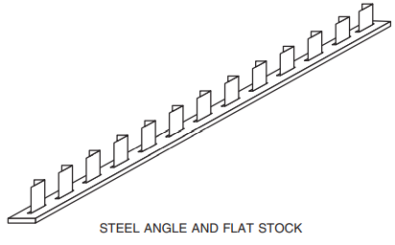
- The table below shows the charges for Electrical installation activities in a workshop.
Activity | Charges per hour
Material preparations | 150
Installation activities | 300
Workshop clean up and house keeping | 100

Additional Benefits are calculated at 10% for preparation 20% for installation and 15% for clean-up. In an eight-hour day an electrician spent 4 hours in preparation, 3 hours in installation and 1 hour in cleaning. Find the total labor costs of installation for 8-hours a day (4 Marks)
- A lecturer’s evening schedule starts at 1545 Hours. There are 20 consecutive appointments of 10 minutes each and one break of 15 minutes. At what time is the lecturers’ evening due to end? Give your answer in 24-hour system. (3 Marks)

- The table below shows the number of conduit pipes sold in a hardware over a duration of two weeks.
Week 1 | 18 | 21 | 21 | 24 | 29 | 20 | 21
Week 2 | 16 | 20 | 18 | 15 | 21 | 18 | 18
- Arrange the values for each week in ascending order (2 Marks)
- Compare the sales for the two weeks and state the week with the highest sales. (2 Marks)
- Find the difference between the mean sales for the two weeks. (4 Marks)
- Two circles of radii 3cm and 2cm have their centres at A and B respectfully. The distance between their centres is 6cm. construct the circles. (4 Marks)
- A washer has an outer radius of 1.8 cm and an inner radius of 0.5cm. Find the shaded area in the diagram, to two decimal place, take$π=\frac{22}{7}$. (3 Marks)
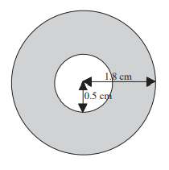

- Given that 1 metre of a quarter inch steel weighs $2\frac{2}{3}kg .$Find the total weight of a $9\frac{3}{4}$ metres long piece. (2 Marks)
- A roller is used to compact the ground before the cabros are laid in place. The diameter of the roller is 0.4m and is used on a path of length 20m. Find to the nearest whole number how many times the roller rotates when rolling on the length of the path once. Take the π on your calculator. (4 Marks)
- A craftsman works 40 hours and earns kshs. 600 per hour for a week. The deductions are
Income tax 18%
Social security 7%
Unions dues 5%
NHIF 2.5%
- Find the net pay for the 40 hours to the nearest whole number (2 Marks)
- Represent the above information in a pie chart in percentage form (4 Marks)

