LEVEL 6

DEMONSTRATE OCCUPATIONAL SAFETY AND HEALTH PRACTICES
Nov. /Dec. 2022



THE KENYA NATIONAL EXAMINATIONS COUNCIL

WRITTEN ASSESSMENT
Time: 3 hours

INSTRUCTIONS TO CANDIDATES
Maximum marks for each question are indicated in brackets ().
This paper consists of TWO sections: A and B.
Answer questions as per instructions in each section.
You are provided with a separate answer booklet.

SECTION A: Short Response Questions (40 MARKS)
Attempt ALL the questions in this section. The maximum marks for each question are indicated.
- The following pictograms are displayed in your workplace. Identify the health safety signs. (2 Marks)

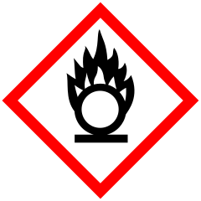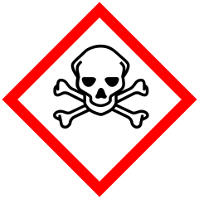
a b
- The following terms are key in occupational and health standards, briefly give your understanding on each of the statements. (3 Marks)
- Accident.
- Safety policy.
- Safety program.
- Define hazard and give FOUR types of hazards in your workplace. (5 Marks)
- Work area is cleaned and made safe before use in accordance with organization policy, outline THREE dangers to the work personnel that are associated with poor cleaning. (3 Marks)
- Identify any FOUR types of safety inspections in your work place. (4 Marks)
- Contingency measures are key in occupational health and safety, give any FIVE basic emergency procedures. (5 Marks)
- In all workplaces, occupational health and safety regulations should be followed, outline any THREE employer’s duties in accordance to OSH Policies. (3 Marks)
- Outline the FIVE procedures followed in implementation of maintaining OSH-related records. (5 Marks)
- You have been requested to carry out an internal safety audit for your company, identify FIVE key elements for compliance. (5 Marks)
- Outline FIVE job factors that could lead to poor health and safety behavior in the
workplace. (5 Marks)

SECTION B: Extended Response Questions (60 Marks)
Attempt at least 3 questions in this section. The maximum marks for each question are 20 Marks.

- Fire hazard is one of the common hazards in different work areas. Fire risks are classified according to the nature of material that is burning, discuss the FOUR classes of fire giving the type of fire extinguishers used in each. (12 Marks)
- You are required to train new staff members in a workplace on hazards encountered. Discuss FOUR common hazards in the workplace. (8 Marks)

- As a safety officer in a workplace, explain FOUR types of information one would obtain from accident incident occurrence report. (8 Marks)
- As an occupational health and safety expert, the general manager has ordered you to carry out risk assessment in your department with the aim of ensuring safety to all the staff. Explain the SIX procedures you will follow to undertake the risk assessment. (12 Marks)
- In a staff meeting, you have been requested to explain to the new staff the safety precautions followed in the company. Discuss TEN safety rules that they must follow. (20 Marks)

- Contingency planning is crucial to the health and safety of everyone within your workplace or facility. Discuss the FIVE contingency planning steps. (10 Marks)
- Injury, damage and loss caused by accidents in workplace can be avoided or minimized where possible. Briefly discuss TEN preventive measures which can be put in place to minimize accidents and injuries. (10 Marks)

