061006T4ICT
ICT Technician Level 6
IT/OS/ICT/CR/11/6
Develop Mobile Application
Nov. /Dec. 2022


THE KENYA NATIONAL EXAMINATIONS COUNCIL

WRITTEN ASSESSMENT
Time: 3 hours

INSTRUCTIONS TO CANDIDATES
Maximum marks for each question are indicated in brackets ( ).
This paper consists of TWO sections: A and B.
Answer questions as per instructions in each section.
You are provided with a separate answer booklet.

This paper consists of SIX (6) printed pages
Candidates should check the question paper to ascertain that all pages are printed as
Indicated and that no questions are missing
SECTION A: (40 MARKS)
Answer ALL questions in this section.
1. Define the meaning of each of the following terms:
i) Mobile application. (2 marks)
ii) Mobile application development architecture. (2 marks)
2. State TWO popular operating systems that a developer can create a mobile application to run on. (2 marks)
3. Explain TWO reasons how a mobile application is different from desktop applications.
(4 marks)
4. Describe TWO mobile development approaches a developer might consider while planning to develop a mobile application. (4 marks)
- Below are statements from AndroidManifest.xml file of a mobile application. Use it to answer the questions that follow;
<application
android:allowBackup="true"
android:label="@string/app_name"
android:roundIcon="@mipmap/ic_launcher_round"
android:theme="@style/Theme.AppCompat.Light.NoActionBar">
<activity
android:name=".AboutActivity"
android:exported="false" />
<activity
android:name=".SettingsActivity"
android:exported="false"
android:label="@string/title_activity_settings"
android:parentActivityName=".MainActivity" />
</Application>
- Explain the importance of such a file. (2 marks)
- Name the TWO activities of the application. (2 marks)
- List TWO navigation patterns used in developing mobile applications. (2 marks)
- Additional files that your application will use are kept in a specific resources directory; name FOUR types of such files. (4 marks)
- Define TWO radio buttons in activity_main.xml file given that the feature loads by default with one option already selected as shown in Figure 1. (3 marks)
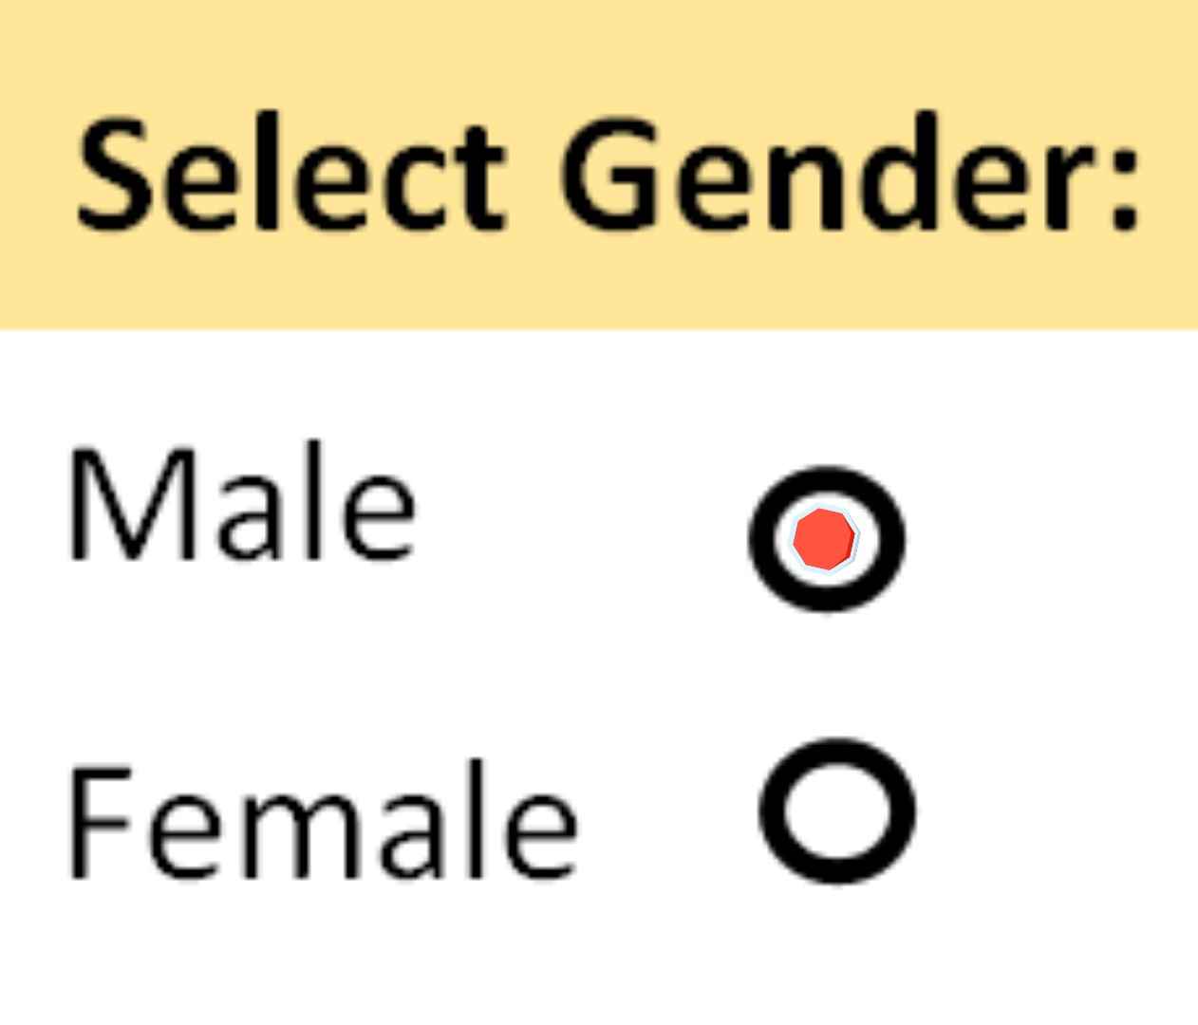
Figure 1
- Distinguish between usability testing and installation testing as used in application development. (4 marks)
- Describe TWO important procedures done after finishing developing a mobile application. (4 marks)
- The following code runs when the user clicks on the button (id=button). This code in a mobile application includes three checkboxes for the question: “Which countries are in East Africa?”
button.setOnClickListener{
if(ChinaCheckBox.isChecked) textresult.text="China: Wrong Answer"
if(KenyaCheckBox.isChecked) textresult.text="Kenya: Correct Answer"
if(TanzaniaCheckBox.isChecked) textresult.text="Tanzania: Correct Answer"
}
- In which file is the method most likely to exist in the development environment.
(1 mark)
- Where will the result appear when the user clicks the button? (2 marks)
- John was developing a mobile application for a client; the requirement was that he needed to incorporate a database for the application. State TWO types of databases that he could use for the application. (2 marks)

SECTION B: (60 MARKS)
Answer any THREE questions in this section.
- a) Explain TWO types of mobile applications. (4 marks)
b) Name FOUR popular Integrated Development Environments (IDE) for mobile application development. (4 marks)
- Usability is an integral part of mobile application development; discuss THREE practices to overcome mobile usability issues. (6 marks)
- Discuss THREE reasons why a business would prefer to build a mobile application than other types of software. (6 marks)
- a) Explain the importance of each of the following directories in an IDE for a mobile application;
- Java Folder; (2 marks)
- Manifest folder; (2 marks)
- Drawable Folder (res/drawable) ; (2 marks)
- Layout Folder (res/layout). (2 marks)
- Describe FOUR main framework components that can be used within a mobile application, naming the component, its description and implementation as a subclass of that component. (12 marks)
- Figure 2 is a designed user interface for a mobile application named myClockApp, displayed in an emulator running the latest version of Android Studio. Use it to answer the questions that follow.
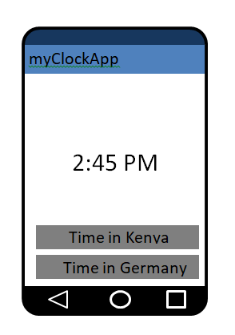
button2
button1
textClock
Figure 2
a) Edit the file activity_main.xml to produce the user interface appearing as in Figure 2.
- button1 (3 marks)
- button2 (3 marks)
- textClock (4 marks)
- Implement event handlers for the two buttons containing text, to switch the time displayed; when button1 is clicked it displays Kenyan time and button2 displays Germany time.
- button1. (5 marks)
(ii). button2. (5 marks)
- You have been hired by Bidii Quality Foods, who wants to expand their restaurant business. Currently, outside customers make telephone calls to order their food to be delivered. They would want you as a mobile application developer to come up with a simple prototype for ordering.
- Using the FOUR main stages of developing a mobile application, describe how you will go about it, mentioning the tools and software involved.
- Setup (3 marks)
- Develop (3 marks)
- Test & Debug (3 marks)
- Publish (3 marks)
- Design TWO activities as they would appear on the screen or emulator i.e. draw smartphone screen snapshots, for;
- The main activity to welcome users, a list of today’s menu and directions to order. (4 marks)
- The next activity after the user has selected one option from the main activity; show user selection, the price and delivery modalities. (4 marks)

