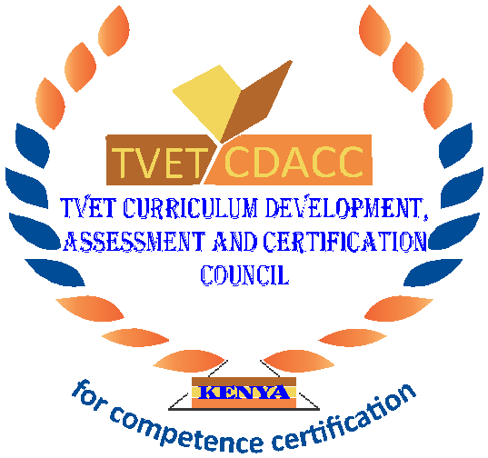
TVET CURRICULUM DEVELOPMENT, ASSESSMENT AND CERTIFICATION COUNCIL (TVET CDACC)

Qualification Code : 102106T4COH
Qualification : Assistant Community Health Level 6
Unit Code : HE/OS/CH/CR/07/6/A
Unit of Competency : Coordinate Community Health Strategies

ASSESSOR WRITTEN GUIDE

This paper consists of SEVEN (7) printed pages
SECTION A (Award 1 Mark each)
- Which of the following statement is true about community health?
- A health care practice that specifically focuses on a group of people with shared characteristics.
- A field of public health that focuses on studying, protecting or improving health within a community.
- A public health study that is compiled by community health workers.
- A modern term for healthcare workers who focus on a group of people with shared characteristics.
- Which of the following is a community-based prevention level?
- Biological level
- Tertiary prevention level.
- Treatment level.
- None of the above.
- The boundaries of community units are determined by?
- Area on map.
- Target population.
- National health committee.
- All of the Above
- Which one of the following is an attribute of community committee members?
- Woman.
- Strong.
- Dependable.
- Moody.
- Health is affected by a number of factors. Which factor below is as a result of behavior and lifestyle?
- Quality of the air we breathe.
- Poverty.
- Family genetics.
- Smoking.
- Roles and responsibilities of Community Health volunteers and committee are
defined based on health guidelines. Which one is a role of a community health volunteer?
- Teaching in schools.
- Advocating for people’s needs.
- Prescribing Drugs in the hospital
- Arresting Defaulters
- ___________________is a need that is related to the treatment, control and prevention of a disease, illness, injury or disability, and the care or aftercare of a person with these needs.
- Training needs assessment
- Community mobilization
- Health care need
- Household health
- Which of the following is a reason why implementation process might fail?
- Lack of ownership
- Community participation
- Sustainability
- Inter-sectoral collaboration
- Which of the following is an Importance of evaluation?
- For Population health.
- For Focus groups.
- To inform in decision making
- All of the above.
- Which one of the following is a method of identifying community health needs?
- Surveys.
- Population health.
- Focus groups.
- All of the above.

SECTION B: (40 Marks)
In this section, each correct answer marks are indicated beside the question.
- Define the following terms; (4 marks)
    - Community health unit.
- It is a structure within a given geographic area for the delivery of health services to a population.
(Award 1 mark)
    - Target population.
-Is a certain group of a population sharing a similar characteristic and which is the intended audience for a product or service.
(Award 1 mark)
    - Community health needs assessment
  - It describes the state of health of local people; through the identification of the major risk factors and causes of ill health and enables the identification of the actions needed to address these.
(Award 2 mark)
- Identify four roles of community health volunteers.
- Collecting community-level data and providing referrals.
- Conducting community dialogue days where information from routine monitoring is used to develop participatory strategies for improving community health and wellbeing.
- Promoting healthy practices and behaviors in the target population during routine household visits.
- Supporting the adoption and maintenance of new health promoting behaviors.
- Providing an example of good health behavior in community action days.
(Award 1 mark for any 4 correct answers)
- Which are any two services offered at a community health unit?
- Immunization
- Water and sanitation hygiene e.g. feacal management, demonstrations on hand washing, household water treatment etc.
- Deworming of children
- First aid services
- Provision of family planning commodities
- Growth monitoring for children under 5 years
- Management of injuries, jiggers, wounds and other minor illnesses
- Tracing of defaulters (ART, TB and immunization)
(Award 1 mark for any 2 correct answers)
- List any four activities for advocacy that Community Health Volunteers can do
- Mobilize the community to come together
- Identify the needs based on the issue at hand
- Explore solutions with the community
- Identify the solutions which need advocacy actions
- Identify the specific target of each advocacy action
- Approach the target using the right communication channels, etc
(Award 1 mark for any 4 correct answers)
- Name four Procedures in conducting community health assessment
- Identify and engage stakeholders
- Define the community
- Collect and analyze data
- Select priority community health issues
- Document and communicate
- Plan improvement strategies
- Implement improvement plans
- Evaluate progress
(Award 1 mark for any 4 correct answers)
- List five conditions necessary to qualify as a Community Health volunteer in Kenya
- Must be a citizen of Kenya
- Must meet the requirements of Chapter Six of the constitution
- Should be above the age of 18 and of sound mind.
- (S)he must be a responsible and respected member of the community
- Is self-supporting and understands that the role of a community health volunteer
does not draw a monthly income
- Is willing and ready to provide services to the community without charging
- (S)he must be a resident (including overnight stay) of respective community that is
selecting him/her for a continuous period of not less than five years prior to the
appointment date
- Is a form four leaver and literate, unless where the situation does not allow
- Is not disqualified for appointment to office by the above criteria or by any law
(Award 1 mark for any 5 correct answers)
- State two Importance of social mobilization
- Raises awareness
- Brings together people from various sides/parties
- Strengthens community participation for more autonomy
- Fosters transparent & accountable decision-making
(Award 1 mark for any 2 correct answers)
- To ensure quality and skills improvement Community Health Volunteers should be continuously mentored and supervised. List three tools used to conduct support supervised
- Training Manuals (On job training manuals)
- Logs
- Checklists
- Job aids
(Award 1 mark for any 3 correct answers)
- Name any four roles of Community Health Committee
- Provision of leadership and oversight in the implementation of health and other
related community services
- Preparation and presentation of the CHU annual work-plans and operational
plans to the link facility health committee
- Planning, coordinating and conducting community dialogue and health action
days
- Working with the link facility to promote facility accountability to the community
- Holding quarterly consultative meetings with the link facility
- Creating an enabling environment for implementation of community health
services
- Resource mobilization for sustainability
(Award 1 mark for any 4 correct answers)
- List any four Methods of identifying community health needs
- Stakeholder meetings
- Surveys
- Interviews with community leaders
- Community focus groups
- Population health
(Award 1 mark for any 4 correct answers)
- Identify three Factors influencing health and wellbeing of community members
- Family environments
- Individual behaviors and beliefs
- Community & work cultures
- Practices & policies
- Socio-economic factors e.g. legislation, media, economics, etc.
(Award 1 mark for any 3 correct answers)
- State two outcomes of health campaigns in the community
- Enables people to have increased control over their health
- Involves the whole population in the context of their everyday lives
- Enables improvement of people’s health
- Promotion of healthy living
- People learn on ways of preventing ill-health
- Shifts the focus from people at risk for specific diseases as people learn preventive measures
(Award 1 mark for any 2 correct answers)

