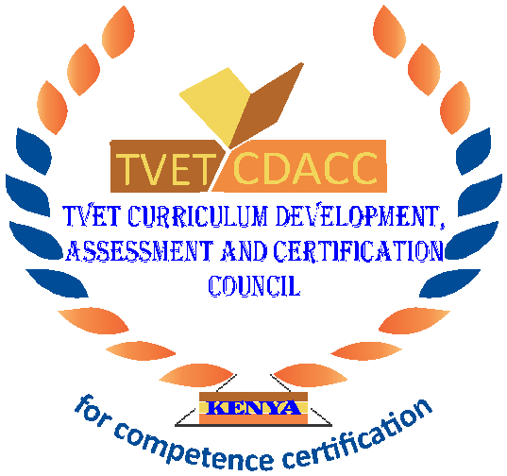
TVET CURRICULUM DEVELOPMENT, ASSESSMENT AND CERTIFICATION COUNCIL (TVET CDACC)

Qualification Code : 102104T4COH
Qualification : Assistant Community Health Level 4
Unit Code : HE/OS/CH/CR/05/4/A
Unit of Competency : Conduct Community Health Strategies

CUTTING LIST

No | Item | Quantity | Provided By
1 | Pens | 1 per candidate | Institution
2 | Answer sheet | 1 per candidate. | Institution
3 | White board | 1 | Institution
4 | Flipchart | 1 per candidate | Institution
5 | Marker pen | 3 | Institution
6 | Water | 1 per candidate | Institution
7 | Sanitizers | 1 | Institution
8 | Masking tape | 1 | Institution

