

TVET CURRICULUM DEVELOPMENT, ASSESSMENT AND CERTIFICATION COUNCIL (TVET CDACC)

Qualification Code : 102105T4COH
Qualification : Community Health Level 5
Unit Code : HE/OS/CH/CC/03/5/A
Unit of Competency : Apply Human Anatomy and Physiology

ASSESSORS GUIDE FOR WRITTEN ASSESSMENT

SECTION A: [20 MARKS]
Award one mark in every correct response in this section
- The life span of red blood cells is:-
  - 60 days
  - 30 days
  - 120 days
  - 140 days
- Atmospheric pressure is an important aspect of:-
- Blood flow
- Micturition
- Breathing
- Reproduction
- Identify the brain structures that regulate respiration :-
- Pons and Medulla
- Thalamus and epithalamus
- Somatic and sensory nervous system
- Cerebellum and cerebrum
- Lymphatic vessels are lined with-
  - Endothelial cells
  - Myocardial cells
  - Cuboidal cells
  - Columnar cells
- The follicular phase is the first:-
  - 16 days of the cycle
  - 12 days of the cycle
  - 19 days of the cycle
  - 14 days of the cycle
- the type of joint associated with the shoulder is:-
  - Gliding joint
  - Saddle joint
  - Ball and socket
  - Slip joint
- Bile is produced in the:-
  - Gall bladder
  - Pancreas
  - Spleen
  - Liver
- The hormones released by posterior pituitary are:-
  - Insulin and thyroxine
  - Oxytocin and insulin
  - Oxytocin and antidiuretic hormone
  - Oxytocin and luteinizing hormone
- The two types of immunity are:-
  - Innate and acquired
  - Innate and developed
  - Extrinsic and intrinsic
  - Passive and excessive
- Urine passes through:-
  - Afferent artery bladder urethra
  - Efferent artery bladder urethra
  - Pelvis of the kidney ureter bladder urethra
  - Pelvis of the kidney urethra bladder ureter
- Sodium reabsorption in the distal convoluted tubule is aided by:-
  - ADH
  - Renin
  - Erythropoietin
  - Aldosterone
- Small hair like structures found on some epithelial cells are:-
  - Villi
  - Diverticula
  - Cilia
  - Microvilli
- Baroreceptors are situated in the :-
  - Arc of the aorta
  - Right atrium
  - Left atrium
  - Left ventricle
- The olfactory bulb contains:-
  - Two layers
  - Three layers
  - Five layers
  - Ten layers
- The heart is located in the :-
  - Abdominal cavity
  - Cranial cavity
  - Thoracic cavity
  - Pelvic cavity
- The function of a tendon is:-
- Link bones to bones
- Link muscle to muscle
- Link joints together
- Link bones to muscle
- Hypertension is diagnosed when the blood pressure reading is:-
  - 40/60 mmHg
  - 90/140 mmHg
  - 90/60 mmHg
  - 140/90 mmHg
- The division of the nervous system that initiates fight or flight response is:-
- Parasympathetic
- Sympathetic
- CNS
- Somatic nervous system
- The most common cancer in Kenya is:-
- Cervical cancer
- Breast cancer
- Esophageal cancer
- Prostate cancer
- An example of an autoimmune disease is:-
  - Tuberculosis
  - Type 1 diabetes
  - Type 2 diabetes
  - Hypertension

SECTION B: [40 MARKS]
Award one mark in every correct response in this section
- Define the following terms:- (4 marks)
  - Antibodies-proteins produced by the immune system to neutralize pathogens
  - Autoimmune disease- the immune system attacks healthy cells in the body
Each point well explained award 2 mark
- Highlight four (4) importance of chewing food (4 marks)
- Moisten food
- Warm or cool food
- Start digestion of starch
- Role food into bolus for swallowing
- Appreciate taste
(Award 1 mark for each of the following)
- List four muscles that form the anterior compartment of the thigh (quadriceps) :- (2 marks)
- Vastus lateralis
- Vastus medialis
- Vastus intermedius
- Rectus femoris
(Award 1/2 mark for each of the following)
- State five (5) hormones of the anterior pituitary glands. (5 marks)
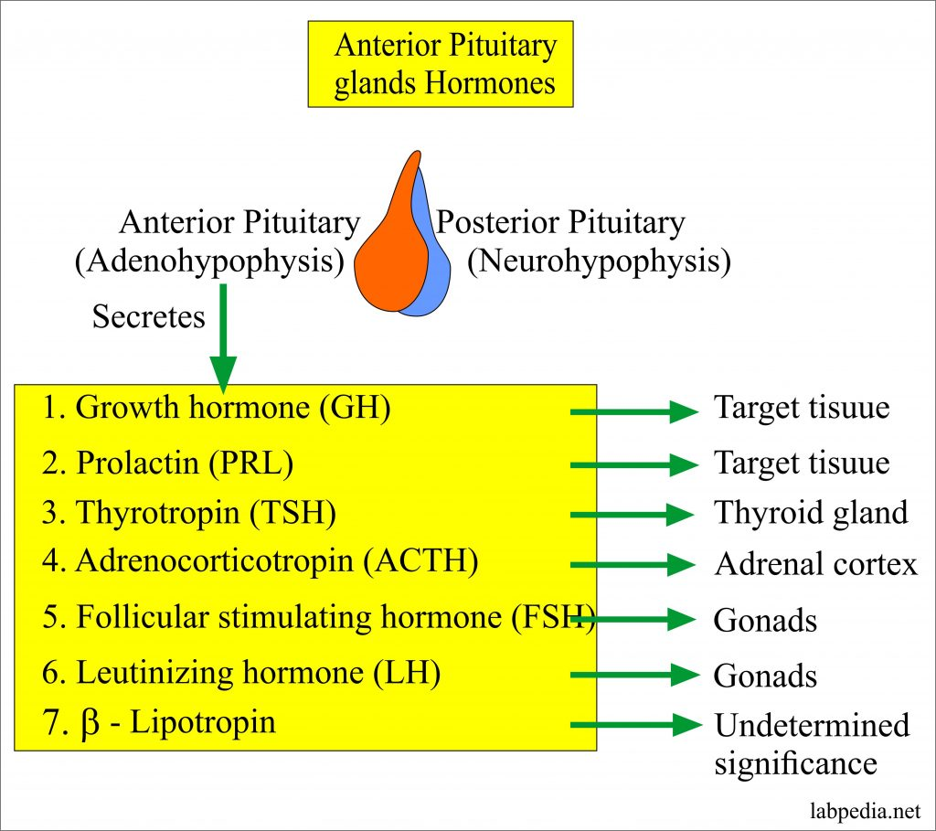
- Draw a well labelled diagram of the Nephron. (5 marks)
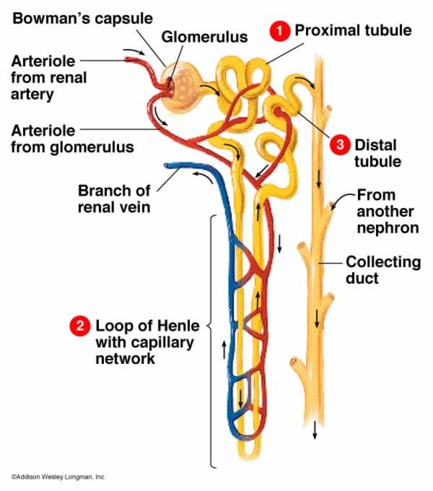
½ mark for title ½ mark for margin 2 marks for correct diagram 2 for correct labeling.
- Outline four (4) functions of the nervous system. (4 marks)
- Short term of blood pressure
- Co-ordinate muscle movement
- Sensation of environmental stimulus
- Interpretation of impulses in the brain and spinal cord
- Generate a response to interpreted sensory information
(Award 1 mark for each of the following)

- State four differences between arteries and veins (4 marks)
Arteries | veins
- Carries blood away from the heart.  - Blood is under high pressure.  - Thick walls  - Pulsation flow  - Narrow lumen  - No valves  - Oxygenated blood except pulmonary artery | - Carries blood to the heart.  - Blood is under low pressure.  - Thin walls  - Smooth flow  - Wide lumen  - Has valves  - Deoxygenated blood except pulmonary vein
(Award 1 mark for each of the following)
- Highlight at least five (5) mode of transmission of HIV/AIDS (5 marks)
- Blood transfusion with Infected
- Contaminated instruments
- Organ transplants
- Having unprotected sex with infected person
- Multiple sex workers with infected people
- Mother to child
(Award 1 mark for each of the following)
- Outline four (4) risk factors associated with cancer. (4 marks)
- genetics
- environmental exposures
- carcinogenic chemicals
- micro-organism exposure; e.g viruses
(Award 1 mark for each of the following)
- Highlight three (3) principles of controlling and eradicating communicable diseases. (3 marks)
- Attacking the source of the disease causing organism
- Interrupting the transmission route
- Protecting the susceptible host
(Award 1 mark for each of the following)

SECTION C: [40 MARKS]
Award marks as guided
- Describe the menstrual cycle under the following sub-headings.
  - Proliferative phase. (10 marks)
Immediately following a menstrual flow (occurring the first 4 or 5 days of a cycle), the endometrium, or lining of the uterus is very thin, only approximately one cell
layer in depth. As the ovary begins to form estrogen (in the follicular fluid, under the direction of the pituitary FSH), the endometrium begins to proliferate, or grow very rapidly, increasing in thickness approximately eight fold. This increase continues for the first half of the menstrual cycle (from approximately day 5 to day 14). This half of a menstrual cycle is termed interchangeably as the proliferative, estrogenic,
follicular, or postmenstrual phase.
  - Secretory phase. (10 marks) What occurs in the next half in a menstrual cycle depends on whether the released ovum meets and is fertilized by spermatozoa. If fertilization does not occur, the corpus luteum in the ovary begins to regress after 8 to 10 days. As it regresses, the
production of progesterone and estrogen decreases. With the withdrawal of progesterone stimulation, the endometrium of the uterus begins to degenerate (at approximately day 24 or day 25 of the cycle). The capillaries rupture, with minute
hemorrhage, the endometrium sloughs off, and menstruation starts
Award 5 marks in every correct well explained response in this section

- The skin is a very vital organ in the body and has a high significance to our survival.
- Draw a well labelled diagram of the skin. (8 marks)
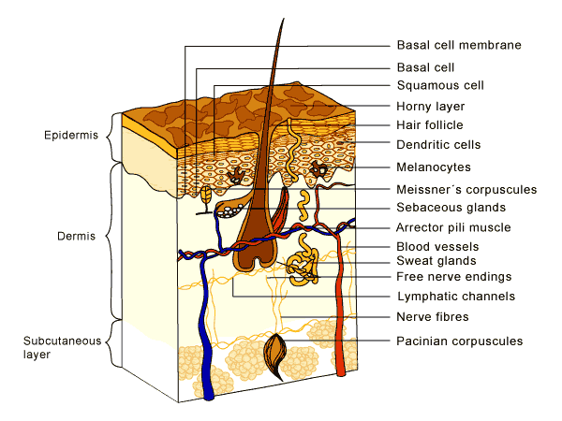

½ mark for title ½ mark for margin 2½marks for correct diagram 2½ for correct labeling.
- Discuss six (6) functions of the skin (12 marks)
- Protection- micro-organisms, dehydration, ultraviolet light, mechanical damage
- Sensation- pain, temperature, touch, pressure
- Endocrine- vitamin D production
- Regulation- temperature regulation
- Excretion- removal of urea, through sweating
- Immunity –secretion of sebum
- Storage- of fats for metabolism as well as insulation
(Award 2 mark for each of the following)

- Diseases are broadly classified under communicable and non-communicable disease compare and contrast the similarities and differences between communicable diseases and non- communicable diseases. . (20 marks)
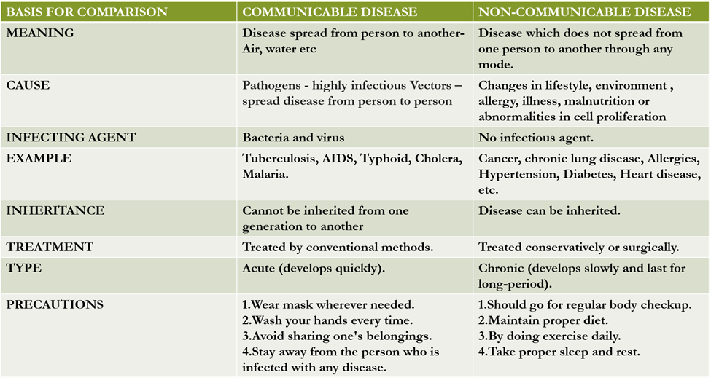
(Award 4 marks for each point compared and contrasted)

