

TVET CURRICULUM DEVELOPMENT, ASSESSMENT AND CERTIFICATION COUNCIL (TVET CDACC)

Qualification Code : 102106T4COH
Qualification : Assistant Community Health Officer Level 6
Unit Code : HE/OS/CH/CC/05/6/A
Unit of Competency : Apply Basic Microbiology and Parasitology

WRITTEN ASSESOR GIUDE
Note to assessor: These are suggested answers to act as guidelines

SECTON A: (40 MARKS)
Note to assessor: These are suggested answers to act as guidelines
- Name three specimens that can be used in laboratory for diagnosis (3marks)
- Blood
- Biopsy
- Urine
- Stool
- Virginal/urethral discharge
- Sputum
$$\left(Award 1×3=3marks\right)$$
- Outline five signs and symptoms of influenza. (5marks)
- Fever
- Chills
- Aching muscles
- Sweats
- Runny nose
- Sneezing
$$\left(Award 1×5=5marks\right)$$

- Differentiate between a definitive host and intermediate host? (2marks)

- Definitive host – a host that harbors a parasite in the adult stage or where the parasites undergo a sexual method of reproduction.
- Intermediate host - harbors the larval stages of the parasite or an asexual cycle of development takes place. In some cases, larval development is completed in two different intermediate hosts, referred to as first and second intermediate hosts.
$$\left(Award 1×2=2marks\right)$$

- Parasites have various negative effects to the host health, which four mechanisms do they use to impose their effect on the host. (4marks)
- Mechanical injury
- Deleterious effect of toxic substances
- Deprivation of nutrients,
- Deprivation of fluids and metabolites
$$\left(Award 1×4=4marks\right)$$

- State the role of bacterial cell wall (1mark)
- It gives bacterial cell its shape
- Protects the cell from drying out
$\left(Award 1×1=1marks\right)$

- Name two types of immunization. (2marks)
- Active immunization
- Passive immunization
$$\left(Award 1×2=5marks\right)$$

- Outline the three symbiotic relationships between a host and parasite (3marks)
- Mutualism
- Commensalisms
- Parasitism
$$\left(Award 1×3=3marks\right)$$

- Community X has been invaded by bed bugs, mosquitoes and cockroaches.
- List three factors that could have contributed to this invasion. (3marks)

- Poor disposal of waste
- Plenty of stagnant waters
- Poor personal hygiene
$$\left(Award 1×3=3marks\right)$$

b) Outline three effects of this invasion to community X? (3marks)

- Irritation and annoyance
- Diseases like malaria
- Food contamination
$$\left(Award 1×3=3marks\right)$$

- Highlight five measures that should be taken to break the transmission cycle and successful parasitic eradication in this community? (5marks)

- Reduction of the source of infection- the parasite is attacked within the host, thereby preventing the dissemination of the infecting agent. Therefore, a prompt diagnosis and treatment of parasitic diseases is an important component in the prevention of dissemination.
- Sanitary control of drinking water and food.
- Proper waste disposal – through establishing safe sewage systems, use of screened latrines, and treatment of night soil.
- The use of insecticides and other chemicals used to control the vector population.
- Protective clothing that would prevent vectors from resting in the surface of the body and inoculate pathogens during their blood meal.
- Good personal hygiene.
- Avoidance of unprotected sexual practices.
$$\left(Award 1×5=5marks\right)$$
- Outline four types of micro-organisms. (4marks)
- Bacteria
- Viruses
- Fungi
- Protozoa
$$\left(Award 1×4=4marks\right)$$

- Your community has high number of patients complaining of stomach ache, vomiting and diarrhea all of which have a history of consuming from a certain kiosk.
- Outline the disease could they be suffering from? (1mark)

- Cholera
$$\left(Award 1×1=1marks\right)$$

- List four factors that could have influenced the spread of this infection . (4marks)
- Untreated drinking water
- Poor disposal of human waste
- Poor personal items
- Overcrowding especially in urban areas.
$$\left(Award 1×4=4marks\right)$$

SECTION B (60 MARKS)
Note to assessor: These are suggested answers to act as guidelines
- Mr. K brings his sick son to hospital complaining of persistent coughing, chest pain and night sweat. Upon consultation the doctor requires a tuberculosis test by culturing the patient’s sputum and the patient sputum tests positive for tuberculosis.
- Using a microbial growth curve describe the phases of microbial growth curve in a batch culture. (10marks)
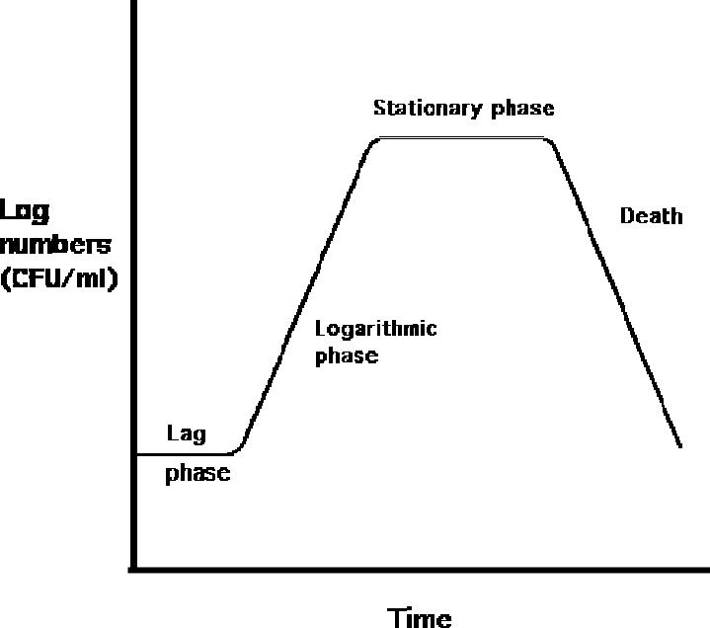

  - Lag Phase - In the lag phase, the number of cells doesn't increase. However, considerable metabolic activity is occurring as the cells prepare to grow. (This phase may not occur, if the cells used to inoculate a new culture are in the log phase & provided conditions are the same).

  - Log Phase (logarithmic or exponential phase) - cell numbers increase exponentially; during each generation time, the number of cells in the population increases by a factor of two). The number of microbes in an exponentially increasing population increases slowly at first, then extremely rapidly. Organisms in a tube of culture medium can maintain log growth for only a limited time, as nutrients are used up, metabolic wastes accumulate, and microbes suffer from oxygen depletion.
  - Stationary Phase - The number of cells doesn't increase, but changes in cells occur: cell become smaller and synthesizes components to help them survive longer periods without growing (some may even produce endospores); the signal to enter this phase may have to do with overcrowding (accumulation of metabolic byproducts, depletion of nutrients, etc.).

  - Death Phase - In this phase, cells begin to die out. Death occurs exponentially, but at a low rate. Death occurs because cells have depleted intracellular ATP reserves. Not all cells necessarily die during this phase!
    - $$\left(Award 2marks for each well explained phase×5=10marks\right)$$
- Describe ways five of preventing and controlling the spread of tuberculosis. . (10 marks)
- Stay home. Don't go to work or school or sleep in a room with other people during the first few weeks of treatment for active tuberculosis.
- Ventilate the room. Tuberculosis germs spread more easily in small closed spaces where air doesn't move. If it's not too cold outdoors, open the windows and use a fan to blow indoor air outside.
- Cover your mouth. Use a tissue to cover your mouth anytime you laugh, sneeze or cough. Put the dirty tissue in a bag, seal it and throw it away.
- Wear a mask. Wearing a surgical mask when you're around other people during the first three weeks of treatment may help lessen the risk of transmission.
- Finish your entire course of medication. This will lessen the chances of transmitting the disease.
- Avoiding overcrowde area

$$\left(Award 2×5=10marks\right)$$
- The coronavirus (Covid-19) is a severe respiratory illness that is highly infectious and has resulted to worldwide concerns due to its spread. As a healthcare worker,
- Describe five the personal protective equipment that you would utilize to control the spread of the disease (10 Marks)
- Apron-worn over the clothing to provide a full front barrier. Used when splashing of bodily fluids is anticipated
- Eye wear/face shield- Worn whenever a risk of splash of body fluids is expected to the face or the eyes
- Gloves- Worn during period of contact with contaminated substances
- Head gear- Worn full length to cover the head
- Boots- waterproof foot ware
$$\left(Award 2×5=10marks\right)$$

- Describe five characteristics of viruses that have made coronavirus difficult to eradicate. (10marks)
  - They are acellular, so not considered prokaryotic or eukaryotic; They are obligate intracellular parasites; when they are outside of a host cell, there is no evidence that these microorganisms are alive.
  - The basic structure of a virus includes a piece of nucleic acid (RNA or DNA) enclosed by a protein coat (capsid); possess no nucleus, organelles, cell membrane, or cytoplasm.
  - Size - 1/10 to 1/1000 the size of an ordinary bacterial cell. Hence easy to escape phagocytosis
  - They are non-motile and only reside inside a host cell.

  - They cause diseases eg HIV/AIDS which has no cure
$$\left(Award 2×5=10marks\right)$$
- Describe in physical, chemical and gaseous methods of sterilization giving examples where necessary (20marks)
- Physical:
Sunlight
Heat: dry heat, Moist Heat
Vibration
Radiation: non-ionizing, ionizing,
Filtration: asbestos, Earthware, membrane, sintered glass
- Chemical
Liquid: alcohol, halogen, phenolic, heavy metals, aldehydes
- Gaseous- plasma, ethylene oxide, formalhydes
Physio-chemical
Award 10 for Physical methods
award 5marks for chemical methods
Award 5 marks for physio-chemical and gaseous methods

- Discuss malarial disease under the following headlines.
- State the Causative agents of malarial diseases (2marks)
- Protozoa, Plasmodium -Plasmodium malaria
$$\left(Award 2 marks for correctly spelled answer=2marks\right)$$
- Explain two main reproductive cycles of protozoa (4marks)
- Asexual
- Sexual cycle
$$\left(Award 2 marks for correct tansmission mode=2marks\right)$$

$$\left(Award 2×2=5marks\right)$$
- Describe five risk factors to malaria. (5marks)
- Low utilization of Insecticidal Treated bed Nets (ITNs),
- Low utilization of Indoor Residual Spray (IRS),
- Availability of multiple mosquito breeding sites or stagnant water sites near the home,
- Staying outdoors overnight
- Travelling to malaria prone zones without vaccination
$$\left(Award 1×5=5marks\right)$$

- Discus six main ways of preventing and controlling malaria (9marks)
- Cover your skin. Wear pants and long-sleeved shirts. Tuck in your shirt, and tuck pant legs into socks.
- Apply insect repellent to skin. Use an insect repellent registered with the Environmental Protection Agency on any exposed skin. These include repellents that contain DEET, picaridin, IR3535, oil of lemon eucalyptus (OLE), para-menthane-3,8-diol (PMD) or 2-undecanone. Do not use a spray directly on your face. Do not use products with OLE or PMD on children under age 3.
- Apply repellent to clothing. Sprays containing permethrin are safe to apply to clothing.
- Sleep under a net. Bed nets, particularly those treated with insecticides, such as permethrin; help prevent mosquito bites while you are sleeping.
- Use of preventive drugs
- Health education

$$\left(Award 1mark*1.5=9marks\right)$$

- Corona virus is one of the most contagious viral diseases. Describe other five viral diseases of public health importance (10marks)
- Flu
- Smallpox
- HIV
- Measles
- Polio
- Hepatitis
(Award 2marks for each correctly explaining the points and 0 for mark for incorrect explanation)
- Discuss five factors that affect microbial growth. (10marks)

- PH – bacteria: acidophiles (acid-loving) – grow best at a pH of 1 to 5.4; E.g. Lactobacilllus (ferments neutrophiles – exist from pH to 5.4 to 8.5; most bacteria that cause human disease are in this category.
- Temperature – bacteria can be classified as: psychrophiles (cold-loving) 15ºC to 20ºC; some can grow at 0ºC. mesophiles - grow best between 25ºC and 40 C; human body temp is 37ºC. thermophiles (heat-loving) – 50ºC to 60ºC; found in compost heaps and in boiling hot springs.
Moisture – only the spores of sport-forming bacteria can exist in a dormant state in a dry environment.
- Hydrostatic pressure – pressure exerted by standing water (eg. lakes, oceans, etc.); some bacteria can only survive in high hydrostatic pressure environments (eg. ocean valleys in excess of 7000 meters); the high pressure is necessary to keep their enzymes in the proper 3-D shape; without it, the enzymes lose their shape and denature and the cell dies.
- Oxygen requirements
Strict or obligate anaerobes – oxygen kills the bacteria; eg. Clostridium tetani
Strict or obligate aerobes – lack of oxygen kills the bacteria; eg. Pserdomonas
Facultative anaerobes – can shift their metabolism (anaerobic if oxygen is absent or aerobic if oxygen is present); eg. E. coli, Staphylococcus.
aerotolerant – the bacteria don’t use oxygen, but oxygen doesn’t harm them; eg.
Lactobacillus microaerophiles – like low oxygen concentrations and higher carbon dioxide concentrations; eg. Campylobacter

- Nutritional (biochemical) factors – Nutrients needed by microorganisms include: Carbon – carbon containing compounds are needed as an energy source (eg. glucose) and for building blocks.
(Award 5marks for correctly explaining the points and 0 for mark for incorrect explanation)

