

TVET CURRICULUM DEVELOPMENT, ASSESSMENT AND CERTIFICATION COUNCIL (TVET CDACC)

Qualification Code : 102106T4COH
Qualification : Assistant Community Health Officer Level 6
Unit Code : HE/OS/CH/CC/04/6/A
Unit of Competency : Apply Human Anatomy and Physiology

ASSESSOR’S GUIDE WRITTEN ASSESSMENT
Note to assessor: These are suggested answers to act as guideline

SECTION A: (40 MARKS)
Note to assessor: These are suggested answers to act as guideline

- Distinguish between anatomy and physiology (2Marks)
- Anatomy – the study of inside and outside of the body (Body structure)
- Physiology – the study of how the human body works (Functions)
$$\left(Award 1mark for the correct answer×2=2 marks\right)$$
- Outline TWO reasons why the knowledge of human Anatomy and Physiology important in Primary health (2 Marks)
- It helps in understanding the health status of patients.
- It helps in assessing, evaluating, diagnosing and tracking a patient’s health
- It helps in understanding areas of the body that different diseases affect $\left(Award 1mark for the correct answer×2=2 marks\right)$
- Highlight three main physiological processes that take place in human cell (3 Marks)
  - Osmosis
  - Active transport
  - Diffusion
(Award 1 mark for the correct point, maximum 3marks)
- Identify four major components of blood (4 Marks)
- Red blood cells – carry oxygen from the lungs to the rest of the body
- White blood cells – help fight infections and aid in immune process
- Platelets (Thrombocytes) – help in blood clotting
- Plasma – Liquid part of the blood
$$\left(Award 2 marks for correct answer and 2 for correct explanation\right)$$
- Outline differences between peristalsis, emesis and digestion (3 Marks)
- Peristalsis – Forward movement of food through the gastrointestinal tract
- Emesis – An act or instance of vomiting
- Digestion – Breakdown of large insoluble food molecules so that they can be absorbed
$$\left(Award 1 for the correct answer×3=3 marks\right)$$
- State TWO (2) major divisions of the central nervous system (4 Marks)
- The central nervous system is made up of the brain and spinal cord
- The peripheral nervous system is made up of nerves that branch off from the spinal cord and extend to all the body parts
$$\left(Award 2×2=4 marks\right)$$
- Name FOUR main endocrine glands and their anatomical locations (4 Marks)
- Hypothalamus (Pituitary and Pineal) – Found in the brain
- Thyroid and parathyroid – In the neck
- Thymus – Between the lungs
- Adrenals – On top of the kidneys
$$\left(Award 2 marks for correct mentioning and 2 for explanation \right)$$
- The skin is the largest organ in the body. List THREE (3) protective functions of the organ (3 Marks)
- Protects against infections
- Against harmful chemicals
- Against water loss
$$\left(Award 1for each correct answer ×3=3 marks\right)$$
- Outline any FOUR (4) digestive enzymes and their functions (4 Marks)
- Amylase – breaks down carbohydrates or starches into sugars
- Lipase – works with the liver bile to break down fats
- Protease – breaks down proteins into amino acids
- Maltase – breaks down malt sugar into glucose
- Lactase – breaks down lactose and sugar found in dry products into glucose and galactose
$$\left(Award 2 marks for correct answer and 2 for explanation\right)$$
- Identify THREE layers of the uterus (3 Marks)
- Endometrium – inner layer that lines the uterus
- Myometrium – Middle ad thickest layer
- Perimetrium – outer serous layer of uterus
$$\left(Award 1for the correct answer×3=3 marks\right)$$
- State TWO hormones produced by the pancreas and their roles (2 Marks)
- Insulin – Act to lower blood pressure
- Glucagon – Acts to raise blood pressure
$$\left(Award 1mark for the correct answer×1=1marks\right)$$
- Name the lergest cell organelles (1mark)
- Nucleus
$$\left(Award 1mark for the correct answer×1=1marks\right)$$
- Outline three chronic obstructive pulmonary diseases (2marks)
- Asthma
- Emphassyema
- Chronic brochitis
- Pneumoconiosis
$$\left(Award 1mark for the correct answer×3=3 marks\right)$$
- List THREE (3) common causes of bone fractures and explain how they occur. . (3 Marks)
- Trauma – can be due to a fall or motor vehicle accident
- Osteoporosis – this disorder weakes bones and makes them more likely to break. Common in old age
- Overuse – repetitive motion can tire the muscels ad place more forece on them
$$\left(Award 1mark for the correct answer×3=3 marks\right)$$

SECTION B: (60 MARKS)
Note to assessor: These are suggested answers to act as guidelines
Only THREE questions attempted

- With an aid of a diagram illustrate the structure of the heart (10 Marks)
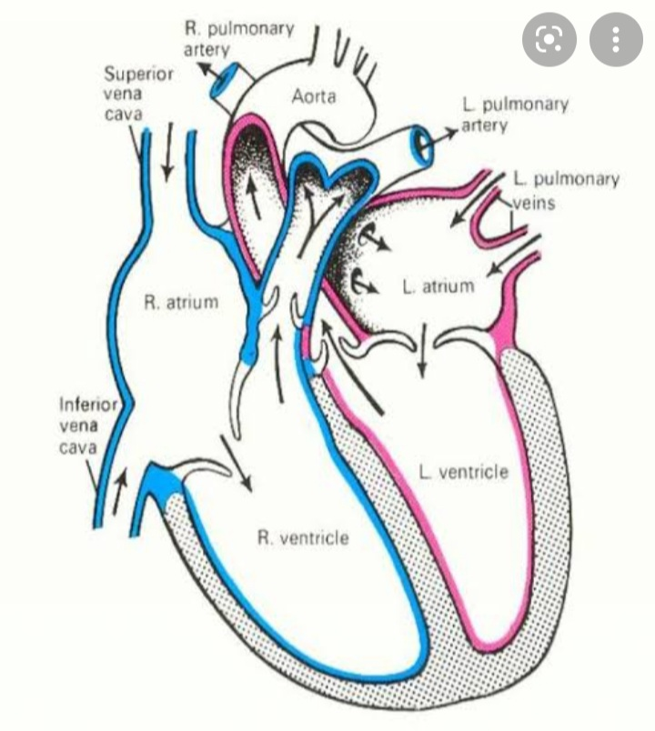
$$\left(Award 5 marks for correct labelling and 5 marks for diagram\right)$$
- Blood circulation system delivers nutrients and oxygen to all cells in the body. It consists of the heart and blood vessels running through the entire body. Discuss the blood circulation process. (5Marks)
- Blood comes into the right atrium from the body through two large veins, the inferior and superior vena cava.
- It then moves into the left ventricle and is pushed into the pulmonary arteries in the lungs.
- After picking up oxygen, the blood travels back to the heart through the pulmonary veins into the left atrium, to the left ventricle and out to the body tissues through the aorta.

$$\left(Award 5marks for the correct answers given, 0 for the incorrect answer\right)$$
- The menstrual cycle is controlled by many different glands and the hormones that glands produce. Identify FOUR phases of menstruation. (5 Marks)
- Menstruation – normal vaginal bleeding that occurs as part of a woman’s monthly cycle. This happens due to shedding of the uterine lining
- Follicular phase – this is the longest step in the menstrual cycle lasting from the first day of a period to ovulation
- Ovulation – occurs when an egg is released from the ovary. May or may not be fertilized by the sperm. If not fertilized, menstrual will still occur
- Luteal phase – this period occur after ovulation ad before a menstrual period/flow starts. The lining of the uterus becomes thick to prepare for a possible pregnancy
$$\left(Award 4 marks for correct answers and 4 marks for explanations\right)$$

- In order for pregnancy to occur, fertilization must take place. Describe the fertilization process and explain what happens if pregnancy does not occur . (12 Marks)
- Fertilization is a process in sexual reproduction.
- It happens when there is a union between the sperm cell and an egg cell in the ampulla of the fallopian tube during ovulation.
- The egg changes so that no other sperm can see it.
- Once fertilization takes place, the newly fertilized cell called a zygote can stay in the fallopian tube for about 3 to 4 days.
- With 24 hours of being fertilized, the cell starts dividing fast into many cells as it moves down slowly through the fallopian tube into the uterus.
- The fertilized egg or zygote then burrows or attaches into the endometrium uterine lining and an embryo starts to grow.
- If the fertilized egg does not implant, the endometrium is shed as menstrual bleeding or period.
$$\left(Award 1× 12=12 marks\right)$$
- Respiration is the process that all living thigs go through to create energy they need to live. With an aid of a well labelled diagram illustrate the structure of respiratory system (8 Marks)
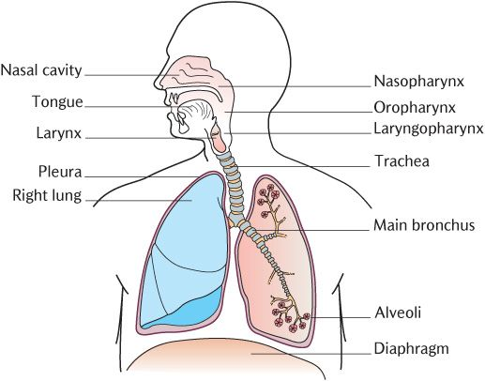
$$\left(Award 4 marks for diagram 4 marks for lebelling ,maximum 8\right)$$

- The urinary system also known as the renal system works with the respiratory, integumentary and digestive organs to let your body work properly. Discuss five main functions of the urinary system. (20 Marks)
- Balances the body’s fluids – the amount of water from the body must equal the amount of water taken in
- Excretion - Removes waste products, medicines and excess water from the body
- Release hormone to control blood pressure – controls the width of your arteries and how much water and salt is moved out of the body.
- Balances a variety of electrolytes – maintains a balance between daily consumption and excretion of electrolytes and water
- Helps the bone health - by controlling calcium and phosphorous
$$\left(Award 5 marks for correct answers and 5 marks for explanation\right)$$
- The human skeleton is the internal framework of the body, and it is composed of 270 bones, but eventually decreases to around 206 bones by adulthood after some get fused together , with reference to this statement attempt the following
  - Explain two major subdivision of human skeleton (4marks)
  - Axial
  - appendicular
(Award 1 mark for stating, one mark for explanation)
  - explain the four types of bones (8marks)
- Long bones
- Short bones
- Flat
- Irregular
(Award 1 mark for stating, one mark for explanation)
  - Outline Five functions of bones (5marks)
- Provide basic framework of the body
- Form a reservoir
- Permit movement
- Red bone marrow
- Supports the body.
- Facilitates movement.
- Protects internal organs.
- Produces blood cells.
- Stores and releases minerals and fat
d). outline three bone diseases (3marks)
- Bone caner
- Osteoporosis
- Rickets
- pageants disease of the bone
- Osteonecrosis
e). Explain four anatomical body movement (8marks)
- Flexion-extension
- Abduction-adduction
- Pronation/supination
- Dorsiflexion
- Circumduction

