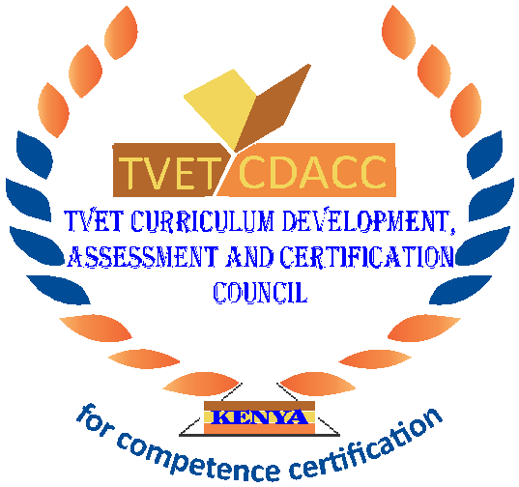
TVET CURRICULUM DEVELOPMENT, ASSESSMENT AND CERTIFICATION COUNCIL (TVET CDACC)

Qualification : Level 5
Unit of Competency : Demonstrate Entrepreneurial Skills

ASSESSOR’S GUIDE WRITTEN ASSESSMENT

This paper consists of 14 printed pages.

SECTION A: (20 MARKS)
In this section, each question carries one (1) mark. Attempt all questions in this section. Choose the correct answer and write it in the answer booklet provided.
- Ability to bring something new into existence in known as?
  - Creativity
  - Innovation
  - Entrepreneurship
  - Motive
- Select a factor that makes a business to grow.
- Giving credit
- Offering donations to the needy
- Minimal supervision of employees
- Keeping detailed financial records
- Which one of the following is an important aspect in marketing?
- Profit
- Price
- People
- Time
- Which of the following is a type of book keeping account?
- Banking account
- Cash book
- Counter book
- Register
- Identify which competence is considered core for a business.
- The ability to inspire and motivate others.
- Convey high integrity and honesty.
- The ability to analyze issues and problem solve.
- All of the above.
- Stakeholders are critical to any organization. Which one is considered an internal stakeholder?
- Business employees
- Government agencies
- Financial institutions
- Social action organizations
- The following are strategies of creating competitive advantages by a business. Which one is not?
- Target market
- Competition
- Cost leadership
- Differentiation
- Identify a source where potential suppliers’ information can be obtained in Kenya among the following.
  - Huduma centers
  - Registrar of companies
  - Business magazines.
  - Bureau of standards
- Point out which is not a benefit of motivating an employee in a business.
- It results to higher productivity levels.
- Lower levels of absenteeism.
- Lower levels of staff turnover.
- It a waste of business resources.
- Which of the following not a factor to consider when scanning a business environment.
  - Security
  - Family
  - Infrastructure
  - Competition
- The most important characteristic of appropriate technology in an enterprise is
    - Effective
    - Expensive.
    - Maintenances
    - Avoidable
- Identify the second phase in the product life cycle.
- Seed and development
- Growth
- Maturity.
- Start-up
- According to Maslow's hierarchy of needs, when all of the physiological needs are met, people tend to become concerned with which of the following?
- social
- self-actualization
- Safety needs
- physiological needs
- The following relate a business plan. Which one best outlines the ideas in whole business plan.
- Market analysis
- Executive summary
- Company description
- Financial plan.
- Which of the following methods is not recommended for collecting customer feedback?
- Phone calls
- Suggestion boxes
- Long term-based survey
- Customer personal-appraisal
- The following are basic entrepreneurial skills. Which one is not?
- Business skills
- Organizational skills
- Communication skills
- Time management skills
- Which of the following is the basic role of book keeping in a business enterprise?
- To create partnership
- To promote accountability and avoid fraud
- To avoid competition
- To market goods and services

- Identify a factor to consider when evaluating a viable business opportunity
- Potential profit
- Play to your strength
- Name of other business owners
- Local politics

- Entrepreneurship is a constant process that relies on ________.
  - creativity, innovation, and profit
  - The ability to win over the consumers
  - Creativity, innovation, and application in the marketplace
  - Intellectual property right

- Which one is not an advantage of entrepreneurship
  - Can chooses a business of interest
  - You can be creative
  - Make a lot of money
  - You will make decisions alone

SECTION B (40 MARKS)
Answer all the questions in this section.

- Briefly define the following terms as used in entrepreneurship. (4marks)
- Business plan
It is a blue print that gives the name of a business, personnel to manage the business, the capital, market and employees required
- Profitability
The ability of a business to earn a profit
It is a measure of an organization’s profit relative to expenses
It is the ability of an organization to use resources to generate revenues in excess of its expenses

- Martin intends to start a business in his rural market. Give five factors he should consider when starting the business (5marks)
- Availability of capital
- State of competition
- Location of the workshop
- Availability of Labour
- Market/demand
- Legal aspects
- Scalability of the business
- Highlight four advantages of a good business plan (4marks)
- Helps one to determine the capital required
- Helps to identify the strengths and weakness of the business
- Used to evaluate the performance of the business
- Used to attract external funding
- Tests business ideas on paper
- Motivates workers and managers

- Identify three reasons why an entrepreneur should establish a business enterprise (3marks)
- For personal satisfaction
- For generating and maximizing profit
- Creation of employment
- Provisions of goods and services
- For prestige
- Highlight five challenges that might be experienced by a new entrepreneur in Kenya (5marks)
- Inadequate capital
- Poor management skills
- Unfriendly government policies and regulations
- Poor infrastructure
- Inappropriate technology
- Unfair competition
- Identify three way in which you can cut unnecessary expenses in your organization. (3marks)
- Modernize marketing strategies
- Use right technology
- Lower office space
- Make people accountable for costs
- Reduce supply expenses
- Cut production costs
- Explain TWO legal documents that may be required when starting a small garage in a rural area. (4marks)
- Legal registration e.g. Registration of business names
- Tax compliance e.g. VAT, income TAX, PAYE
- Trade license e.g. single business permit
- Environmental requirements e.g. NEMA
- Registration with relevant government department
- Zoning regulation e.g. Industrial zone

- Highlight TWO barriers to effective business communications. (4marks)
- Filtering
- selective perception
- information overload
- emotional disconnects
- lack of source familiarity or credibility
- workplace gossip
- semantics
- gender differences
- Mention FOUR major entrepreneurial competencies that enables an entrepreneur to manage an enterprise smoothly. (4marks)
- Time management.
- Financial management.
- Human resource management.
- Conflict management
- Marketing Management
- Social Responsibility
- Leadership
- Decision- making

- As a young automotive technician willing to be an entrepreneur explain TWO sources of finance to raise capital to start a workshop. (4marks)
- Contribution from family and friends
- Personal savings
- Bank/Sacco loans
- Grants

SECTION C (40MARKS)
Answer only TWO questions from this section

- Unemployment has been an issue in Kenya since independence. Young people always wait for white collar jobs after schooling yet there are many opportunities to earn a living with.
  - Describe five ways of generating good business ideas. (10marks)
- Identifying a need in the community: people usually have many unsatisfied needs. By carrying out a market survey on the location where you need to establish your business and talking to the potential customer may reveal gaps in that market.
- Market research: Conduct a market survey and try to identify business opportunities existing in the market. People may be requiring new product/services or the ones existing could be having several weaknesses. These are good opportunities for you.
- Listening to complaints of customers so that you improve an existing business.
- Brainstorming- this involves sitting in a group and trying to think of as many possible businesses as possible using the ‘freewheel 'policy. Take time and digest all the suggested ideas as a basis for making the final decision on the one most suitable for you.
- Creativity - By looking at things in a new way and combining two or more ideas in a new way, such as, one stop shopping spots for customers e.g. a restaurant and a salon combination.
- Business ideas can also be generated through developing personal hobbies and discussions with friends

  - As a young entrepreneur discuss ways in which you can evaluate a business opportunity if it’s viable. (10marks)
A good business opportunity must fulfil or be capable of meeting the following:
- Demand i.e. it should respond to unsatisfied needs or requirements of customers who have ability to purchase and are willing to exercise that choice.
- Return on investment - provide durable, timely and acceptable returns or rewards for the risk and effort required.
- Competitive - Equal to or better - from the viewpoint of the customer - than other available products or services.
- Meet objectives - meet the goals and aspirations of the person taking the risk
- Available resources and competencies - be within the reach of the entrepreneur in terms of resource, competency, legal requirements etc.
- When a business is starting and growing it goes through various stages in its life cycle.
  - Using a diagram discuss the last two stages business life cycle. (10marks)

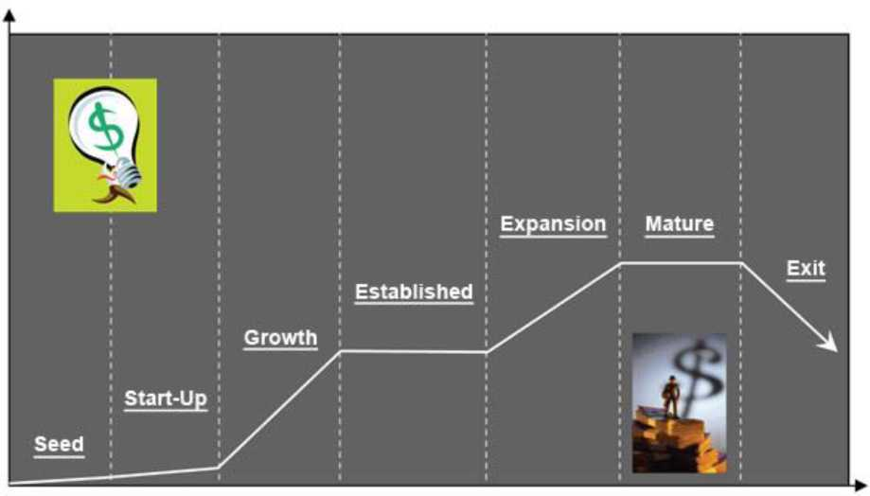

Stage 6: Mature
Businesses in the mature stage of the life cycle will be challenged with dropping sales, profits, and negative cash flow. Search for new opportunities and business ventures. Cutting costs and finding ways to sustain cash flow are vital for the mature stage.
Money Sources: Suppliers, customers, owners, and banks.
Stage 7: Exit
This is the big opportunity for your business to cash out on all the effort and years of hard work. Or it can mean shutting down the business.
  - Recommend five ways in which an entrepreneur can keep his/her business afloat. (10marks)
- Adapting to current market trends
- Find avoidable costs in your business
- Look at your competition
- Accessibility to funds
- Inventory of staff
- Looking for new customers/markets

  - Describe five support service available for small enterprises. (10marks)
- Training services
- Marketing services
- Banking services
- Insurance services
- Postal services
- Management - business mentors
- Technology provision
- Business incubators

  - Discuss five benefits associated with ICT tools in a business. (10marks)

- The Phone
The phone is used to communicate verbally with customers and suppliers. This includes both the fixed line and mobile phones
It is affordable
It is easy to use and any one can understand its functions
- Radio
This is a very effective way to advertise a business
It is quite inexpensive and can reach a wide audience
- Television
A small business may use the television as a tool for sourcing technological information, new products/services, market trends and general information that will assist them
- Print Media
Examples of such are; newspapers, advertising papers/magazines and business directories.
Newspapers e.g. the local dailies (The Nation) which the business enterprise can use to; - Advertise their products/services
- Get information on market trends

- The Computer
This is one of the modern ways of communicating and advertising in use. It can be used in the following ways;
Word processing - writing letters or receipts
Storing information - financial data, customers’ addresses, and suppliers addresses

