
TVET CURRICULUM DEVELOPMENT, ASSESSMENT AND CERTIFICATION COUNCIL (TVET CDACC)

Qualification : Level 5
Unit of Competency : Demonstrate Digital Literacy

ASSESSOR’S GUIDE WRITTEN ASSESSMENT

SECTION A (20 MARKS)
In this section, each correct answer is one (1) mark.
- Which of the following devices CANNOT be considered a computer? [1 Mark]
- Calculator
- Light switch
- Digital Fuel pump
- ATM

- What is the MAIN focus of ICT? [1 Mark]
- Information
- Communication
- Technology
- Informatics

- In what generation of computers were vacuum tubes used? [1 Mark]
- 1st Generation
- 2nd Generation
- 3rd Generation
- 4th Generation

- Computers can be classified according to all the following except? [1 Mark]
- Size
- Purpose
- Functionality
- Shape

- The following are the main enemies of a computer system except? [1 Mark]
- Dust
- Heat
- Wind
- Moisture
- How can one protect computers from fire? [1 Mark]
- Installing burglar-proof locks
- Setting up strong passwords
- Covering the computers with dust covers
- Installing fire extinguishers

- The activities below are all legal except? [1 Mark]
- Packet sniffing
- Deep scanning
- Disk Defragmentation
- Virus database updating

- Which of the following is NOT an application program? [1 Mark]
- Internet browser
- File archiver
- Spreadsheet
- CAD software

- What software below is NOT considered a utility program? [1 Mark]
- Antivirus software
- Screen saver
- Calculator
- Backup utility

- __________ is NOT an example of a Database software. [1 Mark]
- DBase
- Ms Access
- Oracle
- Quickbooks

- How can you define the internet? [1 Mark]
- Interconnection of networks worldwide
- Collection of information found online
- World wide web
- Websites and web pages

- Which of the following is the odd one out? [1 Mark]
- www.facebook.com
- maryjane@gmail.com
- www.google.com
- www.youtube.com

- The following are parts of an email message except? [1 Mark]
- Sender address
- Recipient address
- URL
- Subject

- The following document types are usually designed using DTP except? [1 Mark]
- Calendars, brochures, fliers
- Certificates, newsletters, posters
- Newspapers, magazines, banners
- Letters, memos, minutes

- An element that extends to the edge of a page in DTP is known as; [1 Mark]
- Bleed
- Leading
- Kerning
- Tracking

- Thee spacing between different lines of text in DTP in known as; [1 Mark]
- Bleed
- Leading
- Kerning
- Tracking

- Which paper size below is most suitable when designing a newspaper? [1 Mark]
- A1
- A2
- A3
- A4

- What is a slide? [1 Mark]
- A single page of a presentation
- A collection of pages making up a presentation
- An element within a page of a presentation
- A transition effect of a presentation

- What can you NOT insert within a slide? [1 Mark]
- An image
- An audio clip
- A video clip
- Another slide

- A slide show presentation is suitable for the below activities except? [1 Mark]
- Presenting a proposal to investors
- Demonstrating a procedure in a class
- Conducting a lecture
- Performing a practical

SECTION B: (40 MARKS)
Note to assessor: These are suggested answers to act as guidelines
- Differentiate between the terms software and program. (2 marks)
Software are any parts of a computer system which are not tangible and may include files, data, information, programs; while a program is a set of instructions which guide a computer on what to do. 2 Marks

- Explain TWO ways in which computers are used in industry. (4 marks)
- They are used to automate the manufacturing process by performing tasks that are usually done by human beings.
- They perform tasks that can prove to be risky for human beings, like complex engineering processes.
- They are used for security by use of CCTV cameras and automatic alarms
- They can be used to simulate whole production processes, as is the case with 3D printing.
Any 2 at 2 Marks each

- Outline THREE challenges in the use of computers. (3 marks)
- Use of computers has caused many people to lose jobs after their work was taken over by the computers
- Employees have been deployed to less prestigious jobs after their jobs are now being done by computers
- Use of computers has led to an increase in electronic waste
- Prolonged use of computers had led to health problems like backache and neck pains
- Over-reliance on computers has led to poor development of social skills and interpersonal relations Any 3 at 1 Mark each

- Give any TWO types of viruses. (4 marks)
- Boot sector virus – attacks the computer’s boot files
- Web scripting virus – blends into the background of popular websites disguised as a normal link and tempting you to click
- Resident virus – stores itself in the computer memory and activates itself whenever the computer performs an action
- Browser hijacker – takes over your internet searches and redirects you to pages you did not want to visit
- Trojan horse - disguised as a normal program or file and runs in the background to gain access to your private information
Any 2 at 2 Marks each

- Describe TWO laws which govern the use of ICT in Kenya. (4 marks)
- Kenya Communications Act 2009 – provides the main framework for regulating the communications sector in Kenya
- Access to Information Act – creates a framework to facilitate access to information held by private bodies
- Data Protection Act – seeks to protect Kenyan individuals’ rights and interests and applies to data controllers and data processors. Any 2 at 2 Marks each

- State any THREE types of operating systems. (3 marks)
- Batch operating System
- Multitasking operating system
- Time-sharing operating system
- Real time operating system
- Distributed operating system
- Network Operating system
- Mobile operating system
- Embedded operating system Any 3 at 1 Mark each

- Outline any TWO properties of operating systems. (2 marks)
- Operating systems work using batch processing
- They use multitasking and multiprogramming
- They provide features of interactivity between the system and users
- They facilitate spooling of data and input/ output devices
Any 2 at 1 Mark each

- Explain any TWO types of cell referencing as used in spreadsheets. (4 marks)
- Relative cell referencing – refernces change when a formula is copied to another cell
- Absolute cell referencing – references remain constant no matter where they are copied
- Mixed cell referencing – contains both relative and absolute cell references
Any 2 at 2 Marks each

- What are the TWO main types of network transmission media? (4 marks)
- Guided/ bounded/ wired – signals are confined to a fixed pathway using physical links
- Unguided/ unbounded/ wireless – no physical media is required for transmission of signals
2 Marks each × 2

- Give TWO challenges associated with using the internet. (4 marks)
- Waste of time – one might spend a lot of time online while doing nothing constructive
- Cyber crime – the internet has facilitated some forms of crime which thrive online, like internet fraud, hacking, identity theft, etc
- Pornography – internet provides easy exposure to pornography and other harmful material
- Viruses and malware – the internet exposes our computers to attacks f by viruses and malware.
- Cyber bullying – social media is being used to cause hurt to some users through cyber bullying
Any 2 at 2 Marks

- List any THREE examples of DTP software. (3 marks)

- Microsoft Publisher
- Adobe Pagemaker
- CorelDraw
- Pagestream
- Adobe InDesign Any 3 at 1 Mark each

- Outline THREE advantages of electronic presentations over traditional flipcharts. (3 marks)
- Easy to prepare and edit
- Cheaper to prepare
- Has more variety of presentation features like videos and audio
- Very suitable for summarizing facts
- allows the presenter to face the audience while making the presentation
Any 3 at 1 Mark each

SECTION C: (40 MARKS)
Note to assessor: These are suggested answers to act as guidelines
Only TWO questions attempted.

- List the items needed in order to set up a desktop PC. (6 marks)

- Monitor
- System unit
- Keyboard
- Mouse
- Power cables
- Video/ VGA cable
1 Mark each × 6

- Outline the procedure for assembling a desktop PC. (8 marks)
- Connect the keyboard and mouse to the system unit [2 Marks]
- Connect the monitor to the system unit using the video cable [1 Mark]
- Connect the monitor to mains electricity using a power cable, but do not turn it on [1 Mark]
- Connect the system unit to mains electricity using a power cable, but do not turn it on [1 Mark]
- Confirm that all cables are connected firmly, then power up the system unit and monitor[1 Mark]
2 Marks for correct flow of steps

- Explain THREE advantages of a desktop PC over a laptop. (6 marks)
- Desktop PC is easy to repair and maintain as the components can be easily be detached from the system and replaced.
- It is easy to upgrade since it has provisions for addition of various hardware modules
- Servers for networks are usually designed as desktop PCs, not as laptops
- Desktop PCs do not easily heat up so have lower chances of components frying.
Any 3 at 2 Marks each

- What is a network topology? (2 marks)
This refers to the arrangement of components in a computer network in relation to each other.
2 Marks

- With the aid of diagrams, describe any THREE network topologies. (15 marks)

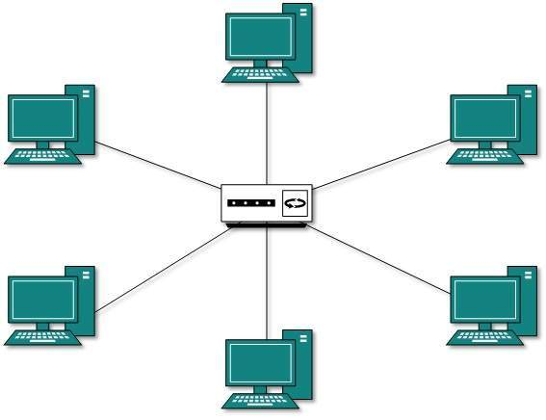
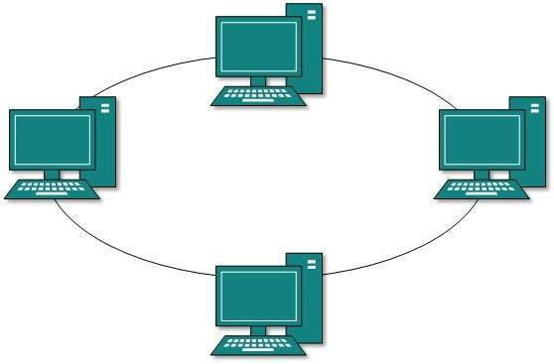
Ring Topology

Star Topology

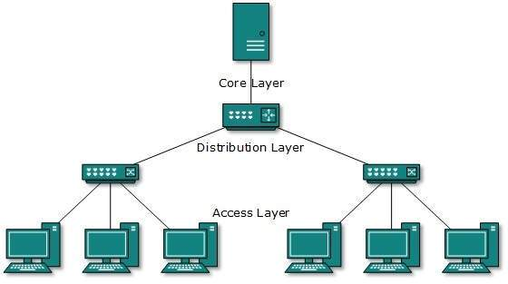
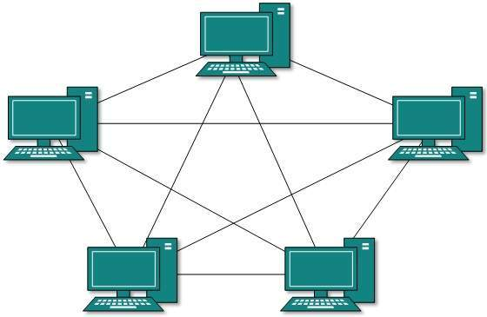
Tree Topology

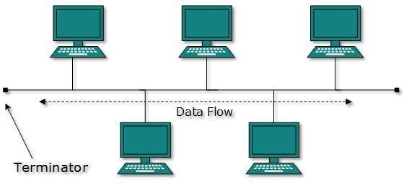
Mesh Topology

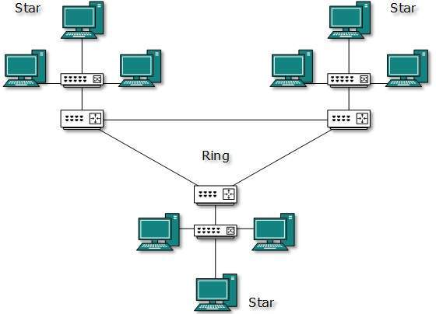
Hybrid Topology
Bus Topology

Any 3 at 5 Marks each

- Outline ONE area where EACH topology given above can be used. (3 marks)
- Ring topology – small business with one office and a few devices
- Start topology – small business with several offices and one server
- Bus topology – computer lab with several computers and a switch
- Tree topology – large organization with several levels of access
- Hybrid topology – large organization with several remote offices
Any 3 at 1 Mark each

- Describe any FIVE categories of computer applications, giving an area of application for each. (10 marks)
- Word processors – used to create electronic word documents
- Spreadsheets - used to perform calculations on large volumes of numeric data
- Databases – used for stroing and manipulating records in an organized manner
- Presentation software – used for making electronic presentations
- Financial accounting – used for working with data in form of currency
- Statistical analysis software – used to perform analysis of large volumes of numeric data
- Browsers – used to open pages on the internet
- Email – used for managing electronic mail messages Any 5 at 2 Marks each

- Describe how the operating system handles each of the following tasks;
- Job scheduling. (2 marks)
Keeping track of time and resources used by various jobs and users. [2 Marks]
- Memory management. (2 marks)
Keeps tracks of primary memory, i.e., what part of it are in use by whom, what part are not in use [2 Marks]
- Input/ Output management. (2 marks)
Keeps tracks of all devices. Program responsible for this task is known as the I/O controller. It decides which process gets the device when and for how much time. [2 Marks]
- Error detection (2 marks)
Production of dumps, error messages, and other debugging and error detecting aids. [2 Marks]
- Processor management. (2 marks)
Keeps tracks of processor and status of process. The program responsible for this task is known as traffic controller. Allocates the processor (CPU) to a process [2 Marks]

