
TVET CURRICULUM DEVELOPMENT, ASSESSMENT AND CERTIFICATION COUNCIL (TVET CDACC)

Qualification : Level 5
Unit of Competency : Demonstrate Numeracy skills

WRITTEN ASSESSMENT

ASSESSOR’S GUIDE

SECTION A: [20 MARKS]
- What is the amount left over when a number can't be divided equally?
- Whole number
- Remainder
- Odd Number
- Divisor
- Choose the fraction equivalent to the decimal 0.09
- 9/10
- 90/10
- 90/100
- 9/100
- On a real number line, what is the midpoint of -4 and 18?
- 8
- 11
- 7
- 4
- How many right angles does a square have?
- 4
- 1
- 24
- 26
- Determine the value of 13-2×3+14÷(2+5)
- 13
- 9
- 15
- 6
- The sum of the measures of two complementary angles is
- 180⁰
- 60⁰
- 45⁰
- 90⁰
- A teacher is organizing an inter-school sport day. There are 8 teams in the competition. Each team must play one game against each of the other teams. What is the total number of games played?
- 8
- 28
- 64
- 54
- A straight line on a d-t graph represents
- Slowing down
- Constant speed
- Speeding up
- No movement
- If a transversal intersects two parallel lines then the interior angles on the same side of the transversal are
  - vertically opposite angles
  - supplementary angles
  - complementary angles
  - alternate angles
- Which of the following are arranged from smallest unit to largest unit?
- Mm, m, cm, km
- Km, m, cm, mm
- Cm,mm,m,km
- Mm, cm,m,km
- What is an object measured in three dimensions of length, width, and height?
- One-dimensional
- Five-dimensional
- Three-dimensional
- Two-dimensional

Which three-dimension figure will be created if a rectangle is rotated about one of its lines of symmetry? (1mk)

Cone

Cube

Cylinder

Triangular prism
- What is ¾ as decimal? (1mk)
- 3.4
- 0.75
- 0.3
- 4.3
- In scientific notation, 20,000 + 3,400,000 =?
- 3.42 × 10⁶
- 3.60 × 10⁶
- 3.42 × 10⁷
- 3.60 × 10⁷
- A map that shows the national and state boundaries, and cities is called a?
- Political map
- Special map
- Population density map
- North Pole map
- A three-dimension shape can be called?
- Flat shape
- Solid
- Polygon
- Hexagon
- A rectangular field is enclosed by 320 feet of fencing. If the length of the field is 6 feet more than its width, what is its length, in feet?
- 80
- 83
- 77
- 157
- Find the value of 1132-757-2315.996-1753.829+2×2846.639=
- 2746
- 2757
- 2656
- 2646
- In a Pie chart, the angels for each sector is calculated by the formula
- Component part × 100
Total
- Component Part × π
Total
- Total × 360⁰
Component Part
- Component Part ×360⁰
Total
- When drawings are drawn smaller than the actual size of the objects the scale used is said to be ___________
- Enlarging scale
- Reducing scale
- Small scale
- Decreasing

SECTION B: [40 MARKS]
- Three tanks are capable of holding 36, 84 and 90 Litres of milk. Determine the capacity of the greatest vessel which can be used to fill each one of them on exact number of times (4mks)
3 36 84 90
2 12 28 30
6 14 15 3x2=6litres
- Three bells ring at intervals of 40 minutes, 45 minutes and 60 minutes. If they ring simultaneous at 6.30 a.m. at what time will they next ring together? (4mks)

2 40 45 60 2³x3²x5
2 20 45 30
2 10 45 15 360min
3 5 45 15 1hr=6cm
3 5 15 15
5 1 1 1 360=6hrs
60 6hrs

6.30
+6
12.30p.m

- Find the equation of the line through the points A (2, 5) and B(3, 11 ) (4mks)

M=11-5=6
3-2 1
=6
Y=6
X
A (2,5 c(x,7)
y/x=y-5 =6
x-2
y-5=6(x-2)
y-5=6x-12
y=6x-7
y=6x-7
- In the figure below, AB X is a tangent. Angle CAB = 17ᵒ and angle ACB = 36ᵒ calculate the size of angle BDC (4mks)
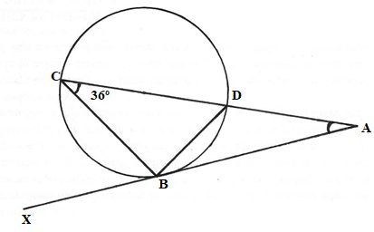
∠ ABD = 360o ( angle formed by a tangent in the opp. Segment).
∠ BDA = 127 ( angle in a Δ)
∴∠ BDC = 180 – 127 = 53o
Or ∠ BDC = 17 + 36 ( exterior angel = opp.inter)
- The sum of interior angles of a regular polygon is 1080º. Find the size of each exterior angle. (4mks)

(2n-4)90
(2n-4)90=1080
180n-360=1080
180n=1080+360
180n=1440
180 180
N=8
1080/8=135

180-135=45º
Or
360/8=45º
- Construct rectangle ABCD in which AB = 4cm and BC = 3cm. Inside the rectangle construct the locus of point L₁ which is 3 cm from A; Locus of L₂ which is equidistant from line AB and AD and locus of point L₃ which is 2cm from line AB. (4mks)

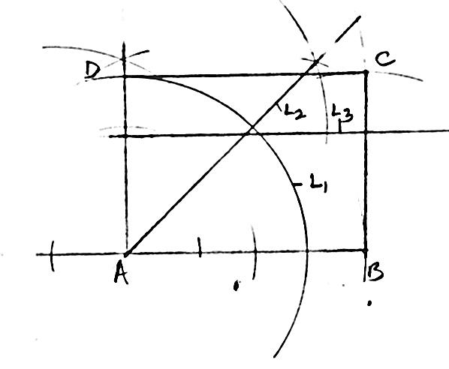

- The table below represents a relationship between two variables x and y.
x | 1 | 2 | 3 | 4 | 5 | 6
y | 3..5 | 4.5 | 8.0 | 8.5 | 11 | 13
    - On a graph paper provided draw the line of best fit. (1mk)
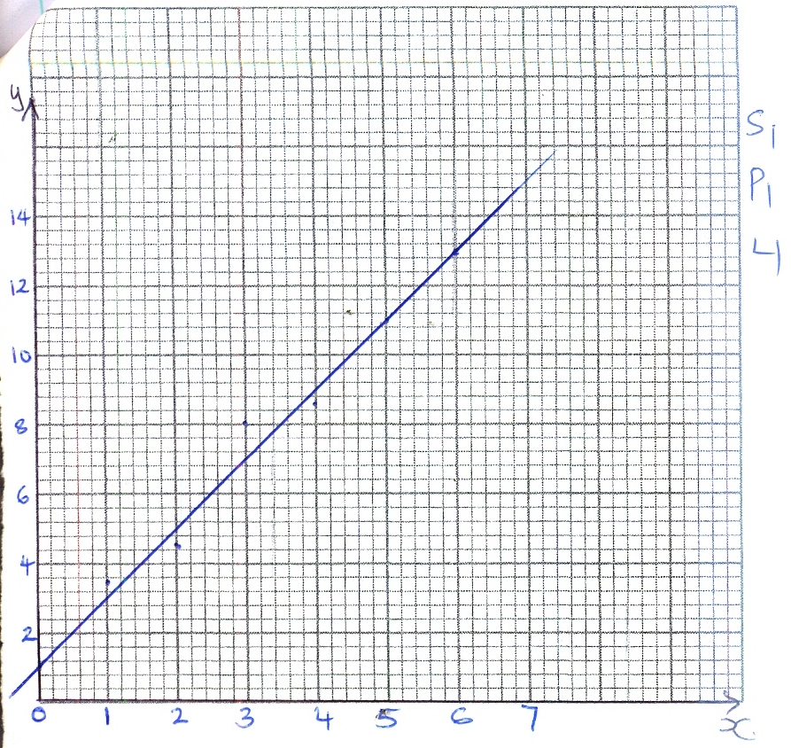

    - Use the graph to find the value of y when x = 0 (3mks)
y = 1

- Using compass and ruler only construct a triangle Arc such that AB= 6cm ,BC = 5cm and angle
ABC = 67.5ᵒ measure the length of AC (4mks)

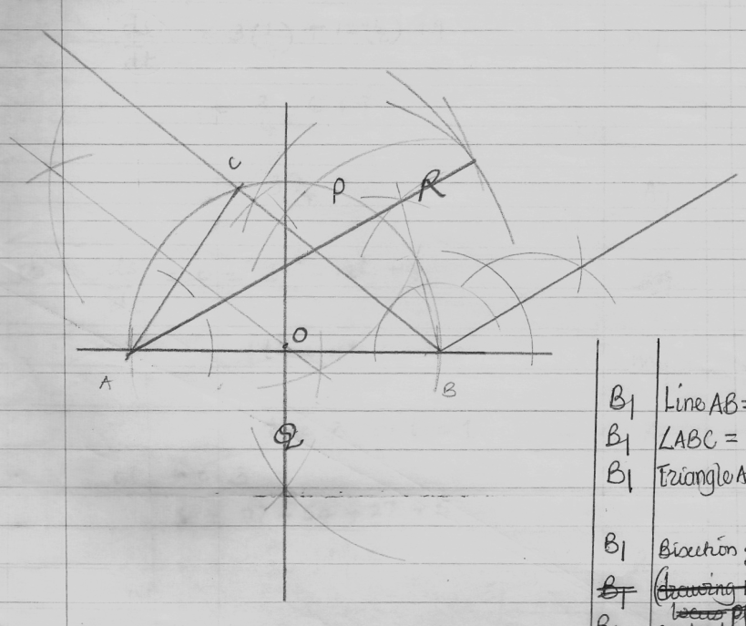

- Evaluate (4mks)
Solution:
- Evaluate
Solution:
SECTION C (40 MARKS)
Attempt Any Two Questions in this section
- Using a ruler and a pair of compasses only, draw a triangle ABC such that AB = 5cm, BC = 8cm and <ABC = 60º. Measure AC and <CAB. (8mks)
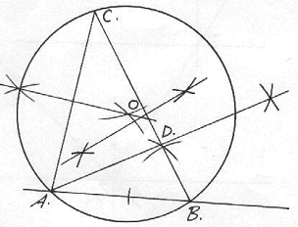
- Find a point O in Δ ABC such that OA = OB = OC. (6mks)
AB=5cm, BC=8cm

∠ABC=60°

AC=7.0 ± 0.1cm

∠BAC=83±1°

⊥ Bisectors of any 2 sides
centre o marked
- Construct a perpendicular from A to BC to meet BC at D. Measure AD. Hence calculate the area of the ΔABC (6mks)
⊥Bisector of BC from A
AD measured 4.3± 0.1
Area=½ x 8 x 4.3
=17.2cm²
- A boy started walking due East from a dormitory 100m South of a bore-hole. He walked to the school library from which the bearing of the bore-hole is 315º. He then walked on a bearing of 030º to the water tank. From the water tank he went west to the bore-hole.
- Using a scale of 1cm to represent 20m, construct a diagram to show the positions of the tank, borehole, dormitory and library. (10mks)
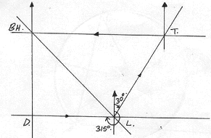
Dormitory located
Tank located
Borehole located
Library located
Correct scale
- Find the distance and bearing of the bore-hole from the water tank. (5mks)
Distance=20x8 =160km
Bearing =270°± 2°
- Calculate the total distance covered by the boy. (5mks)

Total distance walked
= 100+120+160
=380km
- The position of two towns P and Q are given as P(45⁰N, 10⁰W) and Q (45⁰N, 170⁰E).
Find:
- The difference in longitude between the two towns. (2 mk)
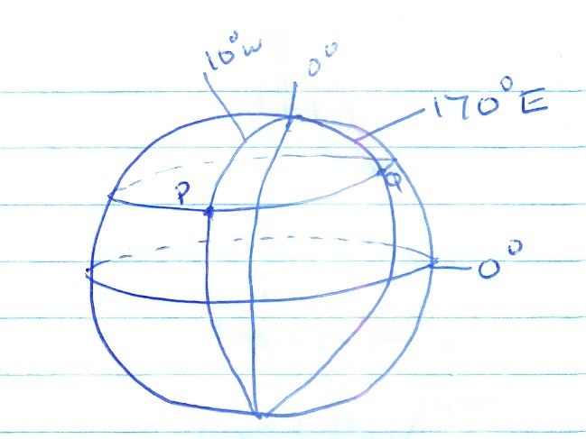
- The distance along the parallel of latitude in
- Km to 1 d.p (4 mks)
- Nm to 1 d.p (4 mks)
- The local time of P when the local time at Q is 2.00pm (4 mks)
- How long would a plane flying at 300 knots take to travel from P to Q along the shortest route. (6 mks)
(Take π = $\frac{22}{7}$) and R = 6370 km
Solution:

