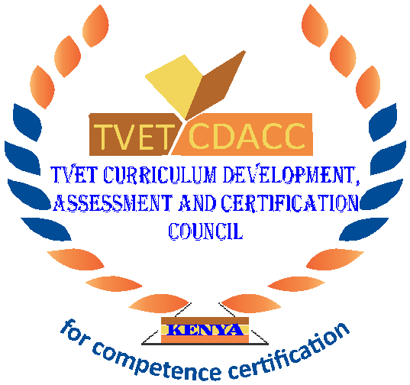
TVET CURRICULUM DEVELOPMENT, ASSESSMENT AND CERTIFICATION COUNCIL (TVET CDACC)

Qualification : Level 4
Unit of Competency : Demonstrate entrepreneurial skills

ASSESSORS GUIDE WRITTEN ASSESSMENT

SECTION A: (10 MARKS)
In this section, each correct answer is one (1) mark. Each question carries one (1) mark.
- Which one of the following is a type of entrepreneurs?
- Traders
- opportunists
- businessman
- skimmers
- Entrepreneurs have several roles to perform in an enterprise. Which one of these is a role?
- Finance
- Marketer
- Innovator
- All of above
- Below are the stages in the creative process. Which one is not?
- Preparation
- Selection
- Evaluation
- Incubation
- Which of following is an internal factor that drives or motivates an individual to become an entrepreneur?
- Family history/parental background
- Government policy
- Courage
- Cost of living
- Which one of the following is not an external factor that motivates entrepreneurial activities?
- Political environment
- Product
- Influence
- Availability
- Which one of the following is a secret to grow your business?
- Tax evasion
- Focus on established revenue
- Flexibility
- Being rigid
- The following are steps to grow your customer base. Which one is not?
- Offer great customer
- Make the most of your networks
- Influence from others
- Look for partnerships with other businesses
- Growth of micro- small enterprises requires entrepreneurial competence. Which one of these is an entrepreneurial competence?
- Workforce
- Employees
- Risk -taking
- Taxation
- Creation of a small-scale business requires competences. Which among the following is a competence?
- Networking
- Leadership
- Financial literacy
- Controlling
- Which one of the following is among the step process to starting a small business?
- Define your vision
- Write a simple action
- Define your workload
- Define your career

SECTION B: (40 MARKS)
Note to assessor: these are suggested answers to act as guidelines.

- List FOUR factors affecting entrepreneurial development. (4 Marks)
- Social / cultural
- Economic
- Political / legal
- Technological
- State THREE qualities of an entrepreneur (3 Marks)
- Sense of independence / autonomy
- Creative or innovative
- Ability to mobilize resources
- Highlight FOUR types of entrepreneurs. (4 Marks)
- Innovators
- Opportunists
- Specialists
- builders
- State FOUR theories of entrepreneurship. (4 Marks)
- Sociological theory
- Economic theory
- Innovative theory
- Psychological theory
- List FIVE ways to manage barriers to creativity and innovation. (5 Marks)
- Keep contact with industry
- Manage negativity appropriately
- Separate creative from productive functions
- Encourage flexibility in the workplace
- Encourage team spirit
- List THREE factors that promote an entrepreneurial culture. (3 Marks)
- Education
- Religion
- Role models
- Highlight FOUR ways of generating business ideas. (4 Marks)
- Market research
- Brainstorming
- Market intermediaries
- Changing government policies
- State THREE methods of evaluating business opportunities. (3Marks)
- Self-analysis
- Capital investment
- Risk assessment

- List THREE stages of motivation. (3 Marks)
- Awareness of need
- Realization of need
- Goal directed behaviour
- Highlight FOUR organizational competences. (4 Marks)
- Managerial skills
- Detail oriented
- Problem solving
- Decision making
- List THREE items that should be included in the plan for small business enterprise
(3 Marks)
- Vision
- Mission
- Objectives

