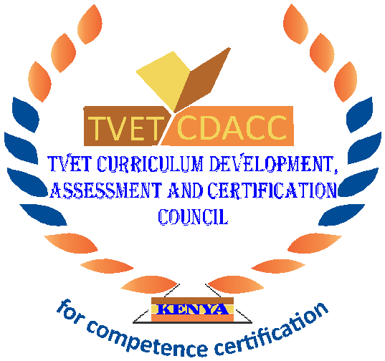
TVET CURRICULUM DEVELOPMENT, ASSESSMENT AND CERTIFICATION COUNCIL (TVET CDACC)

Qualification: Level 4

Unit of Competency: Demonstrate Communication Skills

WRITTEN ASSESSMENT ASSESSOR’S GUIDE

SECTION A (10 MARKS)
Award 1 mark for each correct answer.
- Which one is an example of non-verbal communication? (1 mark)
- Talking on the phone
- Email
- Waving
- Texting on the phone.
- Hearing, thinking about and responding to another person’s message is? (1 mark)
  - Active listening
  - Body language
  - Mixed message
  - Feedback
- Which one of the following is NOT element of a curriculum vitae? (1 mark)
- Reference
- Recommendation
- Work experience
- Executive summary
- The following are factors to consider in selecting a channel of communication except one? (1 mark)
- Confidentiality
- Noise
- Distance
- Geographical distance
- All of the following are examples of verbal communication EXCEPT? (1 mark)
- Email
- Telephone calls
- Radio calls
- Meetings

- Which of the following is NOT a way to show that you’re listening to someone.
(1 mark)
  - Make eye contact
  - Asking questions
  - Leaning back on a chair
  - Sitting upright
- Which one of the following is NOT a type of communication? (1 mark)
- Horizontal communication
- Formal communication
- Intrapersonal communication
- External communication
- Putting yourself in another person’s situation is referred to as? (1 mark)
- Empathy
- Apathy
- Sympathy
- Courtesy
- Television and video clips are the electronic forms of? (1 mark)
- Communication
- Visual communication
- Telecommunication
- Audio communication
- Choose a component of minutes. (1 mark)
  - Appendix
  - Reference
  - Preliminaries
  - Body

SECTION B (40 MARKS)
These are suggested answer to act as guidelines
- List FOUR receiver related barriers to communication (4 marks)
- Poor timing
- Poor listening
- Noise
- Distance
(Award any 4 correct points each 1 mark)
- Define the term encoding as used in communication. (2 marks)
- Encoding which means translating information into a message in the form of symbols that represent ideas or concepts. This process translates the ideas or concepts into the coded message that will be communicated.
(Award 2 marks for a correct answer)
- List FOUR ways through which business people can use Information Communication Technology to interact with their customers. (4 marks)
- Through social media applications such as Facebook, Instagram where businesses can respond to customers questions
- Through business’s websites
- Writing emails to customers
- Responding to their needs through phone calls
- Through videoconferencing
(Award any 4 correct points each 1 mark)
- State THREE elements of a good paragraph. (3 marks)
- A topic sentence
- Supporting/Developing sentences
- A clincher/Concluding sentences
(Award any 3 correct points each 1 mark)
- Highlight THREE types of verbal communication. (3 marks)
- Face-to-face communication
- Telephone conversation
- Radio calls conversation.
(Award any 3 correct points each 1 mark)
- Outline FIVE disadvantages of mobile phones as a means of communication.
(5 marks)
- Some kinds of mobile phones are expensive to buy
- Maintenance expenses of a mobile phone are high. They are also susceptible to damage and repair can be very costly
- Users are greatly inconvenienced in case there is no network coverage
- A special facility where the callers’ identity is known (displayed on screen) can be abused where recipient does not wish to answer the call
- Mobile phones are a security problem. They are easy targets for thieves
(Award any 5 correct points each 1 mark)
- Outline FOUR benefits that may accrue to a business person who uses e-mails to communicate. (4 marks)
- Relatively cheap.
- Relatively fast.
- Enhances confidentiality.
- Sender may get instant feedback.
- Easy to access other information (like advertising).
- Relatively easy to retrieve information.
- It is universal.
- Can advertise to others (wider market).
- Can send detailed information.
- Can be used for future reference/evidence
(Award any 4 correct points each 1 mark)

- Communication is a two way process. Outline FIVE ways in which feedback can lead to the growth of a business or organisation. (5 marks)
- Boosts employees engagement
- Creates a more positive workplace
- It enhances good relations among workers thereby promoting and enhancing their efficiency.
- It used to improve the relationship between the organization and the customer or clients.
- Feedback enables employees to develop awareness of their strengths and weaknesses and help them to improve their performance in future.
- Feedback inspires and motivates people to continue with the good work. It also demotivates them from those activities, which others do not appreciate.
- Openness, trust, and cooperation increases among employees. In personal relationship too, feedback can be used for development purpose.
- When feedback becomes the organization’s culture and philosophy, it will attract high achievers to organizations
- Increase employees morale
- The feedback got from the clients or customers helps to improve an organization’s reliability and quality of goods and services offered.
- Good decisions making
(Award any 5 correct points each 1 mark)
- Outline FIVE key differences between formal and informal communication.
(5 marks)

- Reliability: Formal communication is the more reliable form, as there is a paper trail. Compared to informal communication which has comparatively less reliability, and is very unlikely to have a paper trail.
- Speed: Formal communication is slower, sometimes feeling unbearably slow due to bureaucracy. On the other hand, informal communication is very quick, often being instantaneous.
- Time-Consuming: Formal communication requires a number of different processes before the whole communication flow is complete, whereas informal communication requires very little process time.
- Information Flow: Information through formal communication is only through predefined channels, whereas information through informal communication moves freely.
- Secrecy: Secrecy is maintained with formal communication, whereas informal communication makes it hard to maintain full secrecy due to its reliance on individuals.
(Award any 5 correct points each 1 mark)
- State FIVE reasons why formal communication should be documented in an organization. (5 marks)
- Written communication can be used for litigation to serve as evidence
- Written information can be stored for future reference
- It is not prone to distortions and therefore more accurate
- Written communication is a permanent record in an organization
- Documentation demonstrates professionalism hence sending a positive image to other stakeholders.
- It provides helpful guidance for performance
- Written communication can be used for confidential messages, for example registered mails
- Sometimes, documenting work helps to clarify thoughts and thinking processes as it allows you to mull over things slowly, at your own pace.
(Award any 5 correct points each 1 mark)

