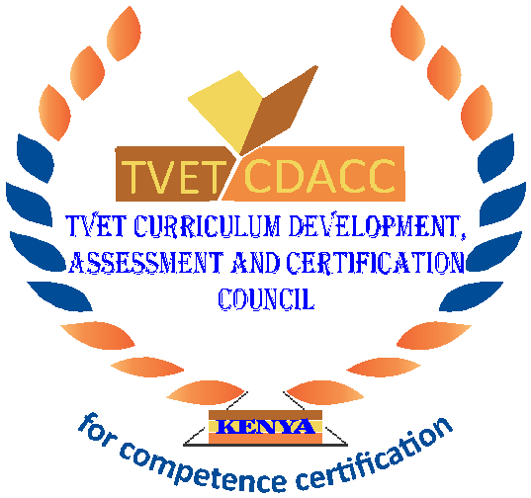
TVET CURRICULUM DEVELOPMENT, ASSESSMENT AND CERTIFICATION COUNCIL (TVET CDACC)

Qualification : Level 4
Unit of Competency : Demonstrate Numeracy skills

WRITTEN ASSESSMENT ASSESSOR’S GUIDE
SECTION A (10 MARKS)
Award 1 mark for each correct answer.
- Which one of the following contains a set of the fractions that are evenly spaced on a number line?
- ¾, 19/24, 5/6
- ¾, 19/24, 7/8
- 4/5, 5/6, 7/8
- ¼, ¾, 7/8
- On a real number line, what is the midpoint of –4 and 18?
- 8
- 7
- 11
- 4
- 14
- What is ¾ as decimal?
- 3.4
- 0.75
- 0.3
- 4.3
- Which decimal is equivalent to 26/9?
- 2.8
- 2.8….
- 2.889
- 2.9
- Which of the following places 4/7, 0.6 and 55% in size order, smallest first?
- 55%, 4/7, 0.6
- 0.6, 4/7, 55%
- 4/7, 55%, 0.6
- 55%, 0.6, 4/7
- How would you write the fraction 2/10 as a decimal?
- 0.2
- 0.02
- 0.002
- 2
- Which 3D shape has six rectangular faces?

Cube

Cuboid

Prism

Tetrahedron
- Vertices are also called?
- Edges
- Corners
- faces
- sides

Which three-dimension figure will be created if a rectangle is rotated about one of its lines of symmetry?

Cone

Cube

Cylinder

Triangular prism

___________shows the four cardinal directions and intermediate directions
- Key
- Compass rose
- Scale
- Symbol

SECTION B: 40 MARKS
11. Using a graph paper draw a line y=x (3mks)
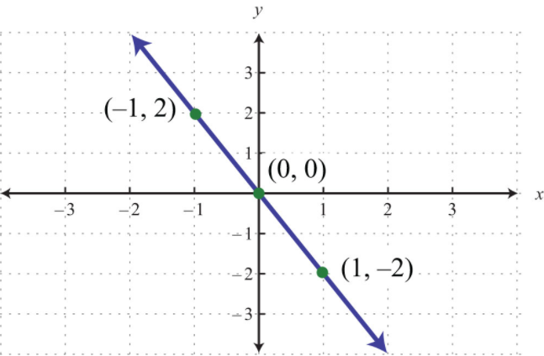
12. State four elements of a map. (5mks)
- Title
- Map key
- Map Scale
- Compass Rose
13. A particular map shows a scale of 1:5000 what is the actual distance if the map distance is 8cm? (3mks)
8: a=1:5000
8/a =1/5000
a/8 =5000
a=8×5000
a=40000
Actual distance=40000 cm
40000/100 m=400m
14. A section of a path is 2m wide and 12m long. It is made from concrete 6cm thick. Find the volume of concrete, giving your answer in m³ (3mks)
The volume of Concrete = Area of rectangle x Depth.
Area of Rectangle = Length x Breadth
Area of a Rectangle=2m× 12m=24m²
Volume of concrete=24×0.06=1.44m³

15. Study the table below and answer the questions.
Height in cm | Numbers of Girls
Less than 140 | 4
Less than 145 | 11
Less than 150 | 29
Less than 155 | 40
Less than 160 | 46
Less than 165 | 51
- What is the average height (in cm) of the girls whose heights are 155 cm and above?
Take value of class interval 155 - 160 and 160 - 165 i.e. 157.5 and 162.5
multiply them by their respective frequency and then divide by total no. of girls
= (157.5×6+162.5×5)/11
= (945+812.5)/11
=1757.5/11
=159.8 cm
- What is the number of girls whose height is above 150 cm?
Change into class interval
Height | No. of girls
135-140 | 4
140-145 | 7
145-150 | 18
150-155 | 11
155-160 | 6
160-165 | 5

Answer: 11+ 6+5=22
16. Work out 20 − 12 ÷ 4 (2mks)
BODMAS RULE: 20-3=17
17. Work out (18 ÷ 3) + (20 ÷ 5) (2mks)
BODMAS RULE: 6+4=10
18. One kilogram is equivalent to _____ grams. (2mks)
1000grams
19. A rectangle measures 20cm by 15cm.If each dimension is increased by 2.5cm, by what percentage is
- The perimeter of the rectangle increased (2mks)
Perimeter=2(L+W)
2(22.5+17.5) =80cm
2.5/80 × 100=3.125%
- The area of the rectangle is increased (2mks)
Area=L×W
22.5×17.5=393.75cm²
2.5/393.75×100=0.006%
20. Using ruler and compasses only,
- Construct triangle ABC in which AB=5cm,BC=6cm and angle ABC=120⁰ (3mks)
- Measure angle ACB (1mk)
- Drop a perpendicular from C to cut AB produced at P (3mks)
- Measure CP (1mk)
- Calculate area of triangle ABC to 1decimal place (1mk)
- Calculate the radius of a circle that passes through the vertices of triangle ABC (3mks)

