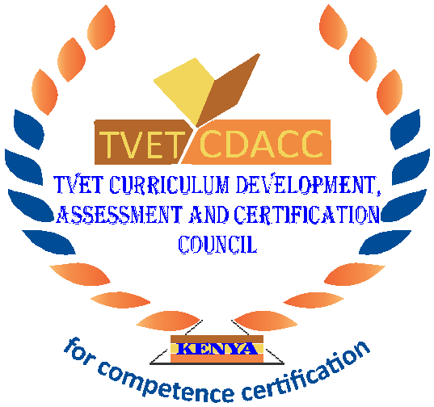
TVET CURRICULUM DEVELOPMENT, ASSESSMENT AND CERTIFICATION COUNCIL (TVET CDACC)

QUALIFICATION: LEVEL 6
UNIT OF COMPETENCY: DEMONSTRATE UNDERSTANDING OF
ENTREPRENEURSHIP

UNIT CODE:

ASSESSOR’ S GUIDE WRITTEN ASSESSMENT
- Marks for each question are indicated in brackets ( ).
- This paper consists of TWO sections: A and B

SECTION A: SHORT ANSWERS (50 MARKS)
- Five social factors that affect entrepreneurship development in Kenya? ( 5 marks)
Include;
- Education
- Churches
- Language Barrier
- Family ties
- Ceremonies
- Beliefs and myths
- Name five sources of business finance? (5 marks)
Include;
- Savings
- Loans
- Donations
- Salary
- Inheritance
- List five barriers to creativity and innovation? (5 marks)
Include;
- Inadequate skills
- Inadequate exposure
- Beauraucracy
- Legal Issues
- Culture
- State five sources of business finance? (5 marks)
Include;
- Salary
- Savings
- Loans
- Donations
- Inheritance
5. Contents of a partnership agreement include; (5 marks)
- Name and address (s) of the firm and the partners.
- Capital to be contributed by each partner.
- The profit-sharing ratios expressed as a fraction or percentage.
- Salaries to be paid to the partners.
- Any interest to be charged on drawings by the partners.
- Interests to be given on partners on their capital balances.
- Procedures to be taken on retirement or admission of a new partner.

6. Five advantages of self-employment as per principles of entrepreneurship. (5marks)

Being your own boss
    - Flexibility
    - Harmony with your life
    - Income generating
    - Profitable

7. Five ways through which entrepreneurs contribute to national development. (5marks)
- Entrepreneurs spur economic growth.
- Boosts national income.
- Entrepreneurs create social change.
- Community development.
- Conservation of foreign exchange.
- Promotion of entrepreneurial culture.
8. Five factors to consider when conducting product demand assessment. (5marks)
    - Go over past sale records
    - Use marketing projections to help estimate demand
    - Use a competitor’s sales data
    - Pay attention to the local and global economy
    - Estimate sales on recent performance
9. Five external factors that are found in the business environment. (5marks)
    - Competition
    - Political
    - Customers and suppliers
    - Economical
    - Technological
10. Five disadvantages of operating a limited company. (5marks)
- Required to pay a registration fee to company’s house to incorporate i.e. legal formalities.
- Company name is subject to certain restrictions.
- More complex and time-consuming accounting requirements.
- Strict procedures for withholding money from the business.
- Owners lose control when the original owners hold less than 51% of shares.
- Selling of shares is expensive because of the commission paid to banks to aid in selling shares and costs of printing the prospectus.

SECTION C: ESSAY/APPLICABLE ANSWERS (50 MARKS)
11. Six stages of a business life cycle include; (10 marks)
- Idea generation: This is the preliminary stage for the business. Here, the entrepreneur does a lot of groundwork to access the viability of the venture he is about to get into.
- Start – up stage: Activities may involve preparation of a formal business plan, registration of the business, sourcing capital, recruiting and designing the product. During this phase, sales are low but slowly increasing its sales as the time passes by. At this phase entrepreneurship concentrates with marketing their product and services to their target customers business are prone to incur losses in this phase.
- Growth stage: at this stage of business common experiences may include:
  - Increased sales and profit
  - Wider market coverage in terms of geographical region
  - A growing number of employees
  - Variety of products and services
  - Increased competition
  - Need for additional expenditures
- Stabilization stage: At this stage, business sales and profits stagnate. The business may also experience intensified competition. Sales may go down due to the presence of competitors in the market profit margin starts to go down.
- Innovation stage: Organizations that fail to innovate at stabilization stage are likely to decline. To ensure come back to growth, the entrepreneur is required to re-look
at the way’s businesses have been conducted. The cash generation is higher than the profit on the income statement.
- Decline stage: This stage is not in normal plan of business. The entrepreneur does not foresee business declining at the start-up stage. Sales and cash flow all decline. Companies accept to extend their business venture by adapting to the changing environment. Firms lose their competitive advantages and finally exit the market.
12. Five challenges that entrepreneurs may encounter when starting and operating small
scale enterprises. (10 marks)
.
- Financial constraints
- Competition
- Lack of advanced technology
- Insecurity
- Hawkers
13. Five sources from which entrepreneurs can generate business ideas. (10 marks)
    - Customer surveys: Customer needs and wants to justify for the service or product that you can offer them.
    - Interests and hobbies: Most people have founded great successful businesses while pursuing their interests and hobbies i.e. by doing what they love doing in their leisure times.
    - Brainstorming and dreams: This starts with identifying a problem statement or question. Designing solution to these problems lead to business ideas.
    - Franchising: It is a situation where sole traders mark distributor of a product gives exclusive rights to independent retailers for local distribution.
    - Mass media: Include T.V. newspapers, internet, radio, and magazines. They are also a great source of ideas, information and opportunities.
    - Personal experience and talents: Most of the ideas are also as a result of experience in a workplace.
    - Trade fairs and exhibitions: Attending such events regularly makes one discover new services and products.
14. Five factors to consider when evaluating the business environment. (10marks) Ability to manage cash
    - Passion and persistence
    - Market size
    - Relationships
    - Management skill sets

15. Importance of creativity and innovation in business (10 marks)
- It helps to solve problems easily in business.
- It increases the productivity of the business.
- Innovation makes it easier to market your business hence gaining market share.
- Have a competitive advantage thus making it easier to beat your competitors.
- Enables the business to sustain in any particular environment.
- A business is able to maximize on its return on investment.
- It brings about a positive impact on the company’s culture.
- Helps in communication and educational accessibility, coming up with effective innovative communication strategies that ensures that communication flows all around the organization

