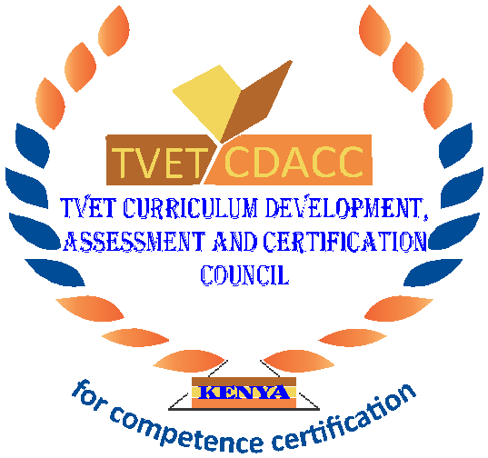
TVET CURRICULUM DEVELOPMENT, ASSESSMENT AND CERTIFICATION COUNCIL (TVET CDACC)

Qualification Code : 061004T4ICT
Qualification : ICT Level 4
Unit Code : IT/OS/ICTA/CC/02/4/A
Unit of Competency : Install Computer Software

WRITTEN ASSESSMENT

INSTRUCTIONS TO CANDIDATE
- Time allocated: THREE (2) hours.
- This paper has three sections A and B. Attempt questions in each section as per instructions given in the section.
- You are provided with a separate answer booklet.
- Marks for each question are indicated in the brackets.
- Do not write on the question paper

SECTION A (10 MARKS)
In this section, each question carries one (1) mark. Attempt all questions in this section. Choose the correct answer and write it in the answer booklet provided.
- A display listing of program options which users can select, is called
- Icons
- Options
- Selection
- Menu
- Which of the following software can’t be categorized as an application software?
- DBM
- MS-DOS
- Spreadsheet
- Word processing
- Your operating system will detect and install the appropriate device drivers for this type of device:
- Plug and play
- Plug and go
- Plug and continue
- Plug and commence
- The component which makes a computer to work through commands is called _____.
- software
- hardware
- malware
- junkware
- Operating system identifies and controls hardware in coordination with _____.
- power cable
- mouse
- SMPS
- BIOS

- During installation of Windows, the computer ______ after copying files, installing features.
- reboots
- keeps on processing
- keeps on beeping
- plays music
- Specialized program that allows the user to utilize in specific application is classified as
- relative program
- application programs
- relative programs
- replicate programs
- The term used to describe the intangible instructions that tell the computer what to do is
- Input/output
- Software
- Hardware
- Storage
- The steps and tasks needed to process data, such as responses to questions or clicking an icon, are called
- The operating system
- The system unit
- Application software
- Instructions
- The ……… manual tells you how to use a software program.
- Technical
- User
- Programming
- Designer

SECTION B (40 MARKS)
Attempt all questions in this section.

- What is Computer Software? (4 marks)
- What is the main function of the operating system? (4 marks)
- With the use of examples, explain the difference between application software and system software. (6 marks)
- The ABC Bauxite company has bought a software package containing several applications to be used for different tasks within the company.
- State the name of the type of package bought by the company. (2 marks)
- Name ONE example of this type of package. (2 marks)
- State TWO advantages and TWO disadvantage of buying this type of software.
(4 marks)
- What is the role of the user interface? (4 marks)
- List four ways of acquiring software in an organization (4 marks)

What is the difference between test scenarios, test cases, and test script? (6 marks)
- List any four types of software requirements you know. (4 marks)

