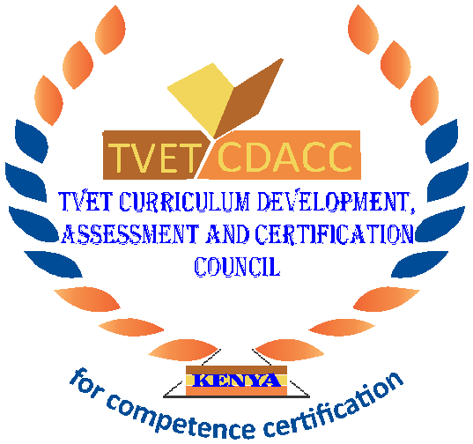
TVET CURRICULUM DEVELOPMENT, ASSESSMENT AND CERTIFICATION COUNCIL (TVET CDACC)

Qualification Code : 061004T4ICT
Qualification : ICT Level 4
Unit Code : IT/OS/ICTA/CC/02/4/A
Unit of Competency : Install Computer Software

WRITTEN ASSESSMENT
ASSESSOR’S GUIDE
SECTION A: (10 Marks)
In this section, each correct answer is 1 mark.
- A display listing of program options which users can select, is called
- Icons
- Options
- Selection
- Menu
- Which of the following software can’t be categorized application software?
- DBM
- MS-DOS
- Spreadsheet
- Word processing
- Your operating system will detect and install the appropriate device drivers for this type of device:
- Plug and play
- Plug and go
- Plug and continue
- Plug and commence
- The component which makes a computer to work through commands is called _____.
- software
- hardware
- malware
- junkware
- Operating system identifies and controls hardware in coordination with _____.
- power cable
- mouse
- SMPS
- BIOS
- During installation of Windows, the computer ______ after copying files, installing features.
- reboots
- keeps on processing
- keeps on beeping
- plays music
- Specialized program that allows the user to utilize in specific application is classified as
- relative program
- application programs
- relative programs
- replicate programs
- The term used to describe the intangible instructions that tell the computer what to do is
- Input/output
- Software
- Hardware
- Storage
- The steps and tasks needed to process data, such as responses to questions or clicking an icon, are called
- The operating system
- The system unit
- Application software
- Instructions
- The ……… manual tells you how to use a software program.
- Technical
- User
- Programming
- Designer

SECTION B: (40 Marks)
Note to assessor: These are suggested answers to act as guidelines
- What is Computer Software? [4 marks]
Computer Software is a programming code executed on a computer processor. It is a set of programs that can do particular work of the user. The software simply is a collection of documentation, instructions, and procedures that are capable of performing different tasks on a computer system.
- What is the main function of the operating system? [4 marks]
The operating system manages the hardware resources of the computer, provides the user-interface components, and provides a platform for software developers to write applications.
- With the use of examples, explain the difference between application software and system software. [6 marks]
Application software programs are packages that carry out specific tasks or solve particular problems e.g.MS office (word, excel access etc.),
System software manages and supports the resources and operations of a computer system and include the operating system (OS) and utility programs Windows 7 and Linux.
- The ABC Bauxite company has bought a software package containing several applications to be used for different tasks within the company.
- State the name of the type of package bought by the company. [2 marks]
- Name ONE example of this type of package. [2 marks]
- State TWO advantages and TWO disadvantage of buying this type of software.
[4 marks]
- The company bought an integrated software package.
- An example of an integrated software package is Microsoft Office.
- Advantages of an integrated software package:
• It takes up less disk space than individual applications.
• You can move much faster from one application to the next.
• It is usually easier to learn, as the user interface for choosing commands is the same.
• It tends to be more powerful and versatile than individual applications.
• It is less likely to crash and contains fewer errors, since it has been widely tried and tested.
• The producers’ after-sales service is often good (such as online help facilities); users can also get support from user groups and magazines.
• It is usually cheaper than purchasing each package separately.
Disadvantages of an integrated software package:
• Not all the features of single applications are included.
• Some integrated packages do not contain all the applications that may be required to complete a task.
• The software may not be suited for use with other well-known software packages.
• The software package may not be unsuited for use by professionals. (Any one)
- What is the role of the user interface? [4 marks]
Answer: The user interface controls how you enter data or instructions and how information displays on the computer screen. Many of today’s software programs have a graphical user interface. A graphical user interface (GUI) combines text, graphics, and other visual images to make software easier to use.
- List four ways of acquiring software in an organization [4 marks]
- Buy Off-the-shelf package - This can be sold through retail outlets without any direct contact between the software developer and the customer.
- Customized software applications - The software developer builds an application that meets the needs of the customer as defined in a specification.
- Lease or Rent software.
- Freeware/Shareware

What is the difference between test scenarios, test cases, and test script?

[6 marks]
Difference between test scenarios and test cases is that
Test Scenarios: A Test Scenario is any functionality that can be tested. It is also called Test Condition or Test Possibility.
Test Cases: It is a document that contains the steps that have to be executed; it has been planned earlier.
Test Script: It is written in a programming language and it’s a short program used to test part of the functionality of the software system. In other words, a written set of steps that should be performed manually.
- List any four types of software requirements you know. [4 marks]
- Functional Requirements.
- Performance Requirements.
- System Technical Requirements.
- Specifications.

