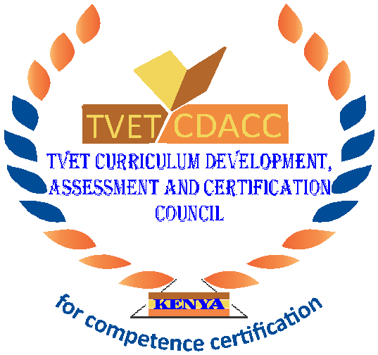
TVET CURRICULUM DEVELOPMENT, ASSESSMENT AND CERTIFICATION COUNCIL (TVET CDACC)

Qualification Code : 061005T4ICT
Qualification : ICT Technician Level 5
Unit Code : IT/OS/ICT/CR/2/5
Unit of Competency : Install Computer Software
WRITTEN ASSESSMENT ASSESSOR’S GUIDE
INSTRUCTIONS TO ASSESSOR
- In this assessment, the candidate will be required to answer written questions.
- Allocate the candidates 3 Hours to answer all the questions.
- Marks for each question are indicated in the brackets.
- The paper consists of THREE sections: A, B and C
- Candidates should answer the questions in English.
- Provide the candidate(s) with a separate answer booklet
- A candidate should write his/her name, registration code, date and sign on the answer booklet.
- These are only to be used as model answers and are subject to further refinement.

SECTION A: SHORT RESPONSE QUESTIONS [40 MARKS]
Award 1 mark to the candidate based on these correct marked answers.
Each question carries one mark
- Which of the following software can categorized as system software? (1 mark)
- DBM
- MS-DOS
- Spreadsheet
- Word Processing
- ________________is a set of instructions given to a computer system to perform a specific task. (1 mark)
- Program
- Data
- File
- Access
- __________works as an interface between computer user and computer hardware. (1 mark)
- Utility software
- Application software
- Virus
- Operating system
- A program that adds functionality to the computer system and ensures smooth functioning of computer system is? (1 mark)
- Application software
- System software
- Utility software
- Ms Outlook
- What features limits the compatibility between Linux and MS-Windows? (1 mark)
- Device drivers
- Folder name
- Log-in Credentials
- Folder size
- Software acquisition is critical when in installing computer software. Which one of the following is a method used in acquiring a software? (1 mark)
- Piracy
- Open source
- Downloading
- Lending
- To safely remove a program from your computer, what type of utility might you want to use? (1 mark)
- Backup program.
- File compression program.
- Troubleshooting program.
- Uninstall program.
- System Software plays a great role in a computer system among the list provided. Which one is not an example of a system software? (1 mark)
- Word Processor
- Language Translator
- Utility Software
- Communication Software
- A person who designs programs in software package is called _________________. (1 mark)
- System Programmer
- System Developer
- User
- Software Manager
- Among the list provided which one is not an operating system? (1 mark)
- Virtual Box
- Sun
- Linux
- Mac

- Which of the following vendors do companies use to provide access to software and services rather than purchasing the application and maintaining the application themselves? (1 mark)
- Open source vendors
- Alliance
- Application service providers
- Software service providers
- What is software installation? (1 mark)
- It is performing service pack
- It is the act of making a program ready for execution.
- It is the act of configuring a software.
- It is step by step process of setting system setting.
- The software tools that enable a user to interact with a computer for specific purposes are known as_____________________. (1 mark)
- Hardware
- Shareware
- Application
- System
- A computer virus is a _______________________. (1 mark)
- Hardware
- Software
- Freeware
- Spam
- _____________is the illegal reproduction and distribution of software application. (1 mark)
- Sorting
- Piracy
- Cracker
- Virus
- Among the list provided, which one is the importance of carrying out software configuration? (1 mark)
- Management
- Accessibility
- Functionality
- Updating
- Which of the following is a utility program? (1 mark)
- Disc defragmenter
- Windows Player
- Word processor
- Games
- What is the difference between a clean installation and an upgrade? (1 mark)
- A clean install includes applications and settings from previous installations.
- An upgrade includes applications and settings from previous installations.
- A clean installation starts by formatting the hard drive.
- There is no difference they are the same.
- What software is always running as long as your operating system is on? (1mark)
- A word processor
- An operating system
- A web browser
- Photoshop
- Which of the following is an example of non-proprietary software? (1mark)
- Windows
- Macintosh
- Linux
- Ms Office 2000

SECTION B: SHORT RESPONSE QUESTIONS [40 MARKS]
Answer all the questions in this section. Marks for each question are indicated in the brackets.
- The word software testing is normally used during software installation. Explain why it’s important. (2 marks)
- Software testing-Software testing is the process of evaluating and verifying that a software product or application does what it is supposed to do.
- When performing software installation, software configuration is one of the elements to be considered. As an expert in this area, describe three software configuration components. (6 marks)
(Allocate two marks for each of the software configuration component described correctly)
- Software configuration identification
- Software configuration control
- Software configuration status accounting and auditing
- An operating system is one of the software considered when installing software, identify four types of operating system. (4 marks)
(Allocate one mark for each type of operating system identified)
- Batch
- Real time
- Distributed
- Single and multitasking
- Single and multi-user
- Backing data is critical before performing the software installation, explain any four ways of backing data. (8 marks)
- USB Stick
- External Hard drive
- Time Machine
- Network Attached storage
- Cloud Storage
(Allocate two marks for each backup discussed)
- System requirements is one of the considerations when installing software. Explain the reason why it is important. (2 marks)
- System requirements are the configuration that a system must have in order for a hardware or software application to run smoothly and efficiently. Failure to meet these requirements can result in installation problems or performance problems.
- User training plays an important role in installing a software. Identify five keys elements to consider when developing an end user training plan. (5 marks)
(Award one mark for any of the key that is correctly identified)
- Determine user skill set.
- Creating a training program.
- Setting training goals.
- Training delivery methods
- Assessing end-user needs
- Techniques of software testing should be considered when carrying out software testing, Explain any two types of software testing techniques. (4 marks)
- Equivalence class partitioning
- Error guessing
- Boundary value analysis
(Award two marks any of the software testing technique that is correctly explained)
- Outline three sources of software installation. (3 marks)
- CD/DVD
- USB drive
- Network share
- Windows Deployment Services
(Allocate one mark for each source given)
- During software installation, software installation checklist is considered. Explain two elements contained in the checklist. (4 marks)
- Plan and build your topology
- Install and Configure each tier
- Perform post-Installation configuration tasks
(Allocate two marks for each element explained)
- Ann was arguing that software configuration was not important. Advise her why it’s important. (2 marks)
- Tracking
- Controlling
(Allocate two marks for each importance explained)

SECTION C: EXTENDED RESPONSE QUESTIONS [40MARKS]
Answer any two questions in this section.
- The principal of Mary Girls’ High school has approached you as an expert to help in installing a management information system on the school’s administration computer. Discuss any five types of installation you may decide to employ. (20 marks)
(Allocate four marks for any of the type of installation explained)
- Unattended
- Schedule/Automated
- Clean/Updating
- Network
- Attended
- Headless
- Juma who had recently purchased a new laptop, for his hardware business, wanted to install a software on it to assist in production of sales receipts. He was however, advised to consider computer requirements before installing any software on his laptop. As an expert in this area, kindly advise Juma on the computer requirements he needs to consider. (20 marks)
(Allocate four marks for any of five computer requirements discussed)
- Operating System.
- Minimum CPU or processor speed.
- Minimum GPU or Video memory.
- Minimum system memory.
- Minimum free storage space.
- Audio hardware (sound card, speakers)
- Portability
- Authenticity
- Availability
- Warranty
- Hardware compatibility
- Bata Company who have recently procured a software to monitor their sales country wide have approached you to assist in carrying out software tests on their installed software. Formulate different types of software tests that you will carry out. (20marks)
(Allocate four marks for any of the five type of testing explained)
- Integration testing.
- Functional testing.
- Unit testing.
- Performance testing.
- Usability testing.
- Regression testing.
- Stress testing.

