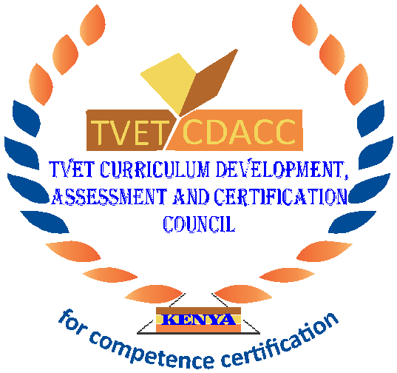
TVET CURRICULUM DEVELOPMENT, ASSESSMENT AND CERTIFICATION COUNCIL (TVET CDACC)

Qualification Code : 061006T4ICT
Qualification : ICT TECHNICIAN LEVEL 6
Unit Code : IT/OS/ICT/CR/02/6/A
Unit of Competency : Install Computer Software

WRITTEN ASSESSMENT ASSESSOR’S GUIDE
(These only serves as a guide to expected responses.)

SECTION A: (40 MARKS)
- Define the term operating system as used in computers? (2 Marks)
It is a type of system software that is used to control the execution of user applications and manage the hardware resources of a computer system and provide the interface between the user and the computer.
(Award 2 marks for each maximum 2 marks)
- Differentiate between white box testing and black box testing (4 Marks)
- White box testing involves testing the product's underlying structure, architecture, and code to verify the input-output flow and enhance design, usability, and security. It focuses on the internal mechanism
- Black box testing involves testing against a system where the code and paths are invisible. It is used for validation where the internal working mechanism are ignored and focus is on the what the output is.
(Award 2 marks for each maximum 4 marks)
- List four importance of software maintenance (4 Marks)
- Bug Fixing
- Capability Enhancement
- Removal of Outdated Functions
- Performance Improvement
(Award 1 mark for each maximum 4 marks)
- Explain the meaning of software maintenance. (2 marks)
- Software maintenance is the process of changing, modifying, and updating software to keep up with customer needs. Software maintenance is done after the product has launched for improving the software, correcting bugs, to boost performance.
(Award 2 marks for each maximum 2 marks)
- Highlight Four advantages of destructive testing. (4 marks)
- Determines the quality of welds
- Entertains compliance with regulations
- Verifies properties of a material
- Helps you to reduce costs, failures, and accidents
(Award 1 mark for each maximum 4 marks)
- Define the term installation manual. (2 Marks)
Software installation refers to the large-scale distribution of software and application on an organizational level.
(Award 2 marks for each maximum 2 marks)
- Identify SIX Key elements to consider before upgrading your operating system. (6 marks)
- Your Current Platform.
- Usability.
- Compatibility.
- Vendor Support.
- Security.
- Upgrade Time & Cost.
(Award 1 mark for each maximum 6 marks)
- Name Eight different operating systems. (8 marks)
- Batched operating system.
- Interactive operating system
- Multi-processing operating system
- Multitasking operating system
- Distributed operating system
- Multi-programmed operating system
- Real-Time operating system
- Timesharing operating system
(Award 1 mark for each maximum 8 marks)
- Explain the function of a software tester. (4 marks)
- Designing test scenarios for software usability
- Conducting the testing
- Analyzing the results
- Submitting observations to the development team
- Interacting with clients to understand product requirements.
(Award 1 mark for each maximum 4 marks)

- Explain the TWO main types of software licenses. (4 Marks)
- Public domain.
- This is the most permissive type of software license. When software is in the public domain, anyone can modify and use the software without any restrictions.
- Permissive.
- They contain minimal requirements about how the software can be modified or redistributed. This type of software license is perhaps the most popular license used with free and open-source software.
(Award 2 marks for each maximum 4 marks)
- Identify TWO approaches used in integration testing. (4 Marks)
- Big Bang Approach
In the big bang integration testing approach, separate components are integrated together and tested at once. This type of testing is convenient when the systems are small and manageable but, in this approach, fault localization is a challenging task.
- Incremental Approach
This is an advanced approach where two or more modules are joined by considering a logical relationship between them. Once a set of the module is tested, more modules are added in the loop until all the modules are assembled and tested. This type of testing is conducted via two approaches – bottom-up and top-down testing.
(Award 2 marks for each maximum 4 marks)

SECTION B: (60 MARKS)
Note to assessor: These are suggested answers to act as guidelines
Only THREE questions attempted
Each question is 20 marks

- a) Discuss FOUR major soft wares acquisition methods. (8 marks)
- Software vendors
- In house developed software
- Open sources
- Packaged software providers
- Information technology firms
(Award 2 marks for each maximum 8 marks)
b) Explain FOUR the factors affecting software acquisition. (8 marks)
- Suitability.
- Scalability.
- Flexibility.
- Support.
- Interoperability.
- Time- to-implementation.
- Implementation risks.
- Property rights.
(Award 2 marks for each maximum 8 marks)
c) Give FOUR benefits of multithreaded programming. (4 marks)
- There is increased responsiveness to the user
- Resource sharing within the process
- Economy
- Utilization of multiprocessing architecture
(Award 1 mark for each maximum 4 marks)

- a) Operating system is the computer most fundamental software. Explain THREE functions of the operating system software. (6 marks)
- Memory management
- Processor management
- Device management
- Files management
- Error detection
(Award 2 marks for each maximum 6 marks)
b) Describe the three-state process model, and their valid transitions which takes place in each in the computer. (6 marks)
- RUNNING
- READY
- BLOCKED.
Valid transitions include:
  - RUNNING to READY - time slice process management.
  - BLOCKED to READY - when a Hardware peripheral becomes free.
  - READY to RUNNING - the scheduler decides it should run.
  - RUNNING to BLOCKED - the process needs some input.
(Award 2 marks for each maximum 6 marks)
c) Highlight FOUR different types of software licenses? (8 marks)
- Public domain.
This is the most permissive type of software license. When software is in the public domain, anyone can modify and use the software without any restrictions.
- Permissive/Apache style/BSD style.
They contain minimal requirements about how the software can be modified or redistributed. This type of software license is perhaps the most popular license used with free and open- source software
- LGPL.
The GNU Lesser General Public License allows you to link to open-source libraries in your software.
- Copyleft/ reciprocal licenses/ restrictive licenses.
These licenses allow you to modify the licensed code and distribute new works based on it, as long as you distribute any new works or adaptations under the same software license.
- Proprietary.
This is the most restrictive. The idea behind it is that all rights are reserved. It’s generally used for proprietary software where the work may not be modified or redistributed
- a) Explain the steps of software maintenance process models. (14 marks)
- Identification & Tracing
The process of determining what part of the software needs to be modified (or maintained). This can be user-generated or identified by the software developer itself depending on the situation and specific fault.
- Analysis
The process of analyzing the suggested modification including understanding the potential effects of such a change. This step typically includes cost analysis to understand if the change is financially worthwhile.
- Design
Designing the new changes using requirement specifications
- Implementation
The process of implementing the new modules by programmers.
- System Testing
Before being launched, the software and system must be tested. This includes the module itself, the system and the module, and the whole system at once.
- Acceptance Testing
Users test the modification for acceptance. This is an important step as users can identify ongoing issues and generate recommendations for more effective implementation and changes.
- Delivery
Software updates or in some cases new installation of the software. This is when the changes arrive at the customers.
(Award 2 mark for each maximum 14)
b) Explain THREE types of software maintenance (6 marks)
- Corrective Software Maintenance
- Preventative Software Maintenance
- Perfective Software Maintenance
- Adaptive Software Maintenance
(Award 1 mark for each maximum 4)
- a) Discuss FIVE benefits of implementing preventive software maintenance. (10marks)
  - It maintains the equipment in good condition to prevent them from bigger problems.
  - Prolongs the effective life of the equipment.
  - Detects the problem at earlier stages.
  - minimizes/eliminates the rework/scrap and helps in reducing the process variability
  - Significantly reduces unplanned downtime.
(Award 2 mark for each maximum 10)
b) Discuss in details software functional and nonfunctional requirements. (10marks)
- Unambiguous.
- Modifiable
- Testable
- Feasible.
- Complete.
- Consistent.
(Award 2 mark for each maximum 10)

THIS IS THE LAST PAGE.

