061004T4ICT
ICT ASSISTANT LEVEL 4
IT/0S/ICTA/CC/04/4/A
APPLY MICROSOFT OFFICE TOOLS
March/April 2023
Time: 2 hours



THE KENYA NATIONAL EXAMINATIONS COUNCIL

WRITTEN ASSESSMENT

2 hours

INSTRUCTIONS TO CANDIDATE
This paper consists of TWO sections: A and B.
Answer ALL the questions from section A and B.
Candidates should answer the questions in English.

SECTION A (10 MARKS)
(Answer all the questions in this section. Each question contains 1 mark)
- Which among the following cell references shows absolute cell referencing as used in Microsoft Excel?
- = G10
- = $G10
- = $G:10
- = $G$10
- ____________________ is a way sending an email copy while keeping the email addresses hidden from the rest of the recipients.
- To:
- Cc:
- Bcc:
- Subject:
- Kelvin wanted to send an email to five (5) of his classmates. Which application would he use?
- Microsoft Excel
- Microsoft Word
- Mozilla Firefox
- Microsoft Outlook
- While entering data in an Excel worksheet, Lina noticed that she had wrongly entered 69 as 96 five times. Which command should she use to rectify the error at once?
- Find and Save
- Find and Replace
- Go To and Replace
- Sort and Filter

- Identify the object that is used for data entry in Microsoft Access.
- Cell
- Report
- Form
- Field
- ___________ is a method of sorting data in Microsoft Excel from the largest to the smallest value.
- Ascending
- Descending
- Largest
- Custom
- From the diagram below, which option can one select in order to save a typed Microsoft Word document using a password?
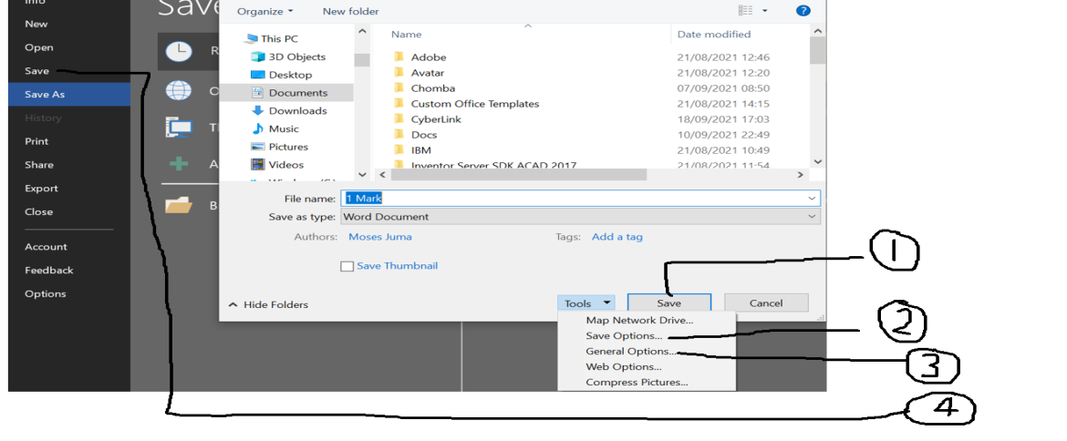
- 1
- 2
- 3
- 4
- _____________ is a power point view used to display each slide as a thumbnail and rearranges slides:
- Slide Master
- Slide Show
- Notes Page
- Slide Sorter

- Which of the following formats best suits the date (_ _/_ _/ _ _ _ _)?
- General date
- Short date
- Medium date
- Long date
- Select the section that does not exist in a slide layout from the list below:
- Pictures
- Titles
- Animations
- Charts

SECTION B: (40 MARKS)
Answer all the questions. Marks for each question is indicated in brackets
- Differentiate between primary and foreign keys as used in databases. (2 Marks)
- Explain the function of each of the following parts of a worksheet: (4 Marks)
- Name box;
- Formula bar.
- The fees balance of students in a college is entered in a worksheet from cell D3 to D10.
Write a formula that would be used to calculate the number of candidates whose fees
balance is more than 20,000. (2 Marks)
- Describe TWO types of relationships that are used to manipulate data in Microsoft
Access. (4 Marks)
- Using an example, describe mixed cell referencing as used in Microsoft Excel. (2 Marks)
- Explain the function of the following action queries used in databases:
- Update;
- Append. (4 Marks)
- Differentiate between bound and unbound controls as used in Microsoft Access. (2 Marks)
- A student intends to create a document. After proper consideration on which
application to use, he decided to use a word processor. Outline three advantages of
his choice. (3 Marks)
- Figure 1 shows icons found on the standard toolbar of a word processor program.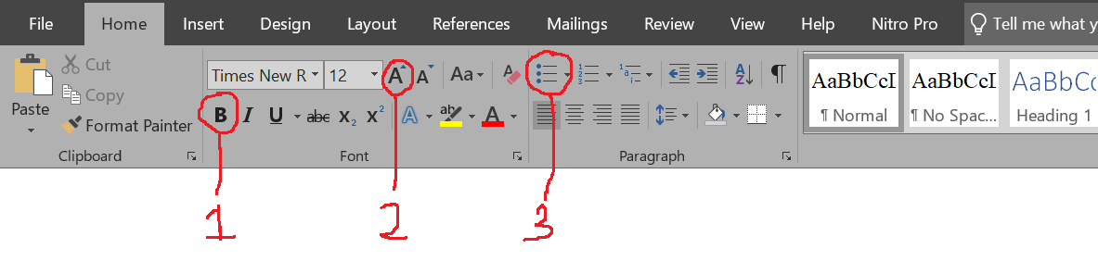
Figure 1
Describe the function of the icons labeled 1, 2 and 3. (3 Marks)
- The following are features of Microsoft Word: Indent, strikethrough, thesaurus and sort. Classify them as either editing or formatting features. (4 Marks)
- Using a suitable example, outline THREE parts of an email. (4 Marks)
- Alice would like to apply slide transition to her presentation. List THREE examples of transition effects she could use. (3 Marks)

- Atieno would like to create a PowerPoint presentation. List THREE ways she could achieve this. (3 Marks)

THIS IS THE PRINTED LAST PAGE

