Demonstrate Numeracy Skills Level 5
3 Hours
March/April 2023


THE KENYA NATIONAL EXAMINATIONS COUNCIL
WRITTEN ASSESSMENT

Time: 3 hours

INSTRUCTIONS TO CANDIDATE
This paper consists of THREE sections A, B and C.
Answer ALL questions in sections A, B and TWO questions in section C in the answer booklet provided.
Marks for each question are indicated in brackets.
You should have a non-programmable calculator.
Do not write on this question paper.
Answer the questions in English.

This paper consists of TEN (10) printed pages.
Candidate should check the question paper to ascertain that
all the pages are printed as indicated and that no questions are missing.

SECTION A (20 MARKS)
- Find the next number in the pattern 2, 6, 12, 20, 30, … (1Mark)
- 36
- 40
- 42
- 50
- Convert the recurring decimal 0.$\dot{7}$ into fraction (1Mark)
- $\frac{7}{10}$
- $\frac{9}{7}$
- $\frac{77}{100}$
- $\frac{7}{9}$
- Figure 1 represents a vegetable garden. (1Mark)
Figure 1 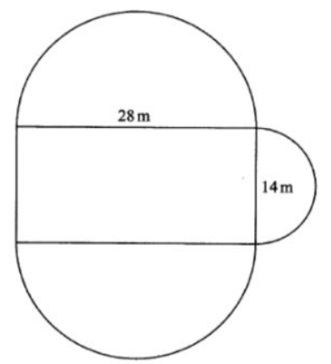
Find the area of the garden in square metres. Take $π=\frac{22}{7}$ (1Mark)
- $693m^{2}$
- 1008m²
- $1085m^{2}$
- $1162m^{2}$
- The interior angle of a regular polygon is ${108}^{0}$. Find the number of sides of the polygon
(1Mark)
- 5
- 6
- 4
- 3

- Determine the value of: $13-2×3+14÷ (2+5)$ (1Mark)
- 13
- 9
- 15
- 6
- Safi wholesalers packed 15 cartons each containing 20 bottles of juice. The amount of juice in each bottle was 250ml. Find the total amount of juice, in litres. (1Mark)
- 75
- 750
- 7500
- 150
- Mr. Kamau is organizing an inter-school sports day. There are 8 teams in the competition. Each team must play one game against each of the other teams. How many games were played. (1Mark)
- 8
- 28
- 64
- 54
- A straight line on a distance-time graph represents. (1Mark)
- Slowing down
- Constant speed
- Speeding up
- No movement

- Table 1 shows the number of people visiting the immigration office for six days. (1Mark)
Table 1
Day | Mon | Tue | Wed | Thurs. | Fri | Sat
Number of people | 55 | 75 | x | 19 | y | 122

If x is less than y by 1 and the total number of people were 414, find the values of x and y.
- x=70, y=69
- x=72, y=71
- x=71, y=70
- x=73, y=72
- The pictogram in figure 2 was used to represent the number of pan-cakes baked
. 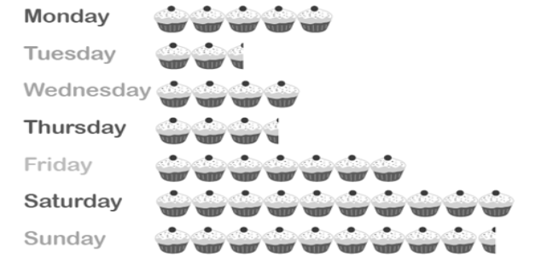
Figure 2
If the total number of pan-cakes represented in figure 2 were 6059, how many pan-cakes were baked on Thursday? (1Mark)
- 511
- 584
- 1731
- 3.5
- Nice Rice Company sold 2.5 tons of rice in 2kg packets. How many packets were sold? (1Mark)
- 1.25
- 1250
- 2500
- 5

When a rectangle is rotated about one of its lines of symmetry, which figure will be formed? (1Mark)

Cone

Cube

Cylinder

Triangular prism
- Table 2 shows the number of candidates who sat for examinations in two years.
Table 2
Year | 1 | 2
Boys | 367125 | 381600
Girls | 328652 | 345454
How many candidates in year 2 exceeded year 1. (1Mark)
- 74619
- 31277
- 16802
- 14475
- Evaluate: $\frac{7}{9}of\left(\frac{3}{4}-\frac{1}{3}\right)+\frac{2}{5}\left(10÷-2\right)$ and express your answer in 3 decimal form.
(1Mark)
- -1.676
- 1.676
- -1.675
- 1.675
- The area of a sector whose radius is 7cm is 23.1cm² Find the angle of the sector. (1Mark)
- 154⁰
- 54⁰
- 27⁰
- 108⁰

- On a map, the distance between two towns A and B is 20cm. Using a scale of 1cm to represent 10km. Find the actual distance between the two towns. (1Mark)
- 10km
- 2km
- 20km
- 200km
- A carpenter recorded the following measurements for four items, 9.5 m, 8.5m, 108cm,234dm respectively. Find the total measurement in centimeters. (1Mark)
- 1931.4cm
- 2628cm
- 4248cm
- 19314cm
- Find the perimeter of the work piece shown below (1Mark)
Figure 3 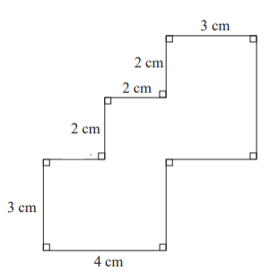
    - 24
    - 28
    - 26
    - 25

- A rectangular flower garden is enclosed by 320 metres of barbed wire. If the length of the garden is 6 metres more than its width, find its length. (1Mark)
- 80m
- 83m
- 77m
- 157m
- Table 3 shows the charges for carpentry activities in a workshop.
Table 3
Activity | Charges per hour in Ksh.
Material preparations | 150
carpentry activities | 300
Workshop clean-up and housekeeping | 100
Find the amount of money paid to a technician who works for 2 ½ hours in each activity.
(1Mark)
- Ksh.1375
- Ksh.550
- Ksh.1000
- Ksh.1100

SECTION B: [40 MARKS]
Answer ALL the questions in this section
- Find the slant height of a circular cone whose base diameter is 6cm and the volume is 66cm³. (4Marks)
- Three bells ring at intervals of 30 minutes, 50 minutes and 55 minutes. If they ring simultaneously at 8.30 a.m on a Sunday. At what time will they next ring together?
(4Marks)
- A line passes through the points A (2, 4) and B (3, 6), Find the equation of its perpendicular bisector . (5Marks)
- In figure 4, angle BAC = 18ᵒ, angle ACB = 35ᵒ and ABX is a tangent at B. calculate the size of angle BDC (4Marks)
Figure 4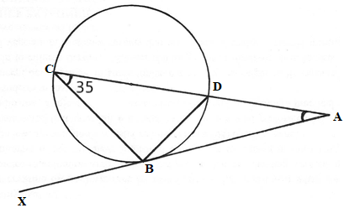
- A candidate scored 60% in math, 70% in metal work, 80% in business studies, 75% in ICT, and 55% in applied science. Represent the score in a pie chart. (5 Marks)
- Table 4 represents a relationship between two variables x and y.
Table 4
x | 1 | 2 | 3 | 4 | 5 | 6
y | 3.5 | 4.5 | 8.0 | 8.5 | 11 | 13

- On a graph paper provided draw the line of best fit; (3Marks)
- Use the graph to find the y intercept. (1Mark)
- The sum of interior angles of a regular polygon is 1080º. Find the size of each exterior angle. (3Marks)
- Using compass and ruler only, construct a triangle such that AB= 6cm, BC = 5cm and angle ABC = 67.5⁰. Measure the length of AC. (4Marks)
- Evaluate:
(3Marks)
- Mutuku scored the following marks in eight subjects, 55, 65, 90, 55, 75, 85, 80,70. Find the:
- Median mark; (2Marks)
- Mean mark. (2Marks)

SECTION C (40 MARKS)
Answer TWO questions in this section
- The age categories of persons treated in a hospital for a week is as shown in table 5.
Table 5
AGE | NUMBER OF PERSONS
1-10 | 30
11-20 | 40
21-30 | 60
31-40 | 35
41-50 | 25
51-60 | 15
- State the modal class; (1Mark)
- How many people above 30 years were treated; (2Marks)
- Find the median of the distribution; (4Marks)
- Find the mean of the data; (4Marks)
- Determine the standard deviation; (4Marks)
- Construct a histogram of frequency against the actual class boundaries. (5Marks)
- (a) Given that $n=\frac{IR}{E-Ir}$, find the value of I given that n = 2.4, r = 0.01. R = 3.6 and
E = 8.5 (5Marks)
(b) Abdi walked due East from a hostel 100m South of a bore-hole, then to the
School library from which the bearing of the bore-hole is 315º. He then walked on a
bearing of 030º to the water tank and finally straight to the bore-hole.
- Using a scale of 1cm to represent 20m, construct a diagram to show the positions of the tank, borehole, dormitory and library; (9Marks)
- Find the distance and bearing of the bore-hole from the water tank; (3Marks)
- Calculate the total distance covered by Abdi. (3Marks)

- A block of copper having a mass of 50 kg is drawn out to make 500 m of wire of uniform cross-section. Given that the density of copper is 8.91 g/cm³, calculate;
- The volume of copper; (4Marks)
- The cross-sectional area of the wire; (5Marks)
- The diameter of the cross-section of the wire; (5Marks)
- The wire is cut into two pieces in the ratio 2:3. The longer part of the wire is used to make small circular components diameter 14cm and the other part rectangular components length 6cm with width 4cm. How many components were made in each case? (6 Marks)

THIS IS THE LAST PRINTED PAGE.

