Demonstrate Numeracy Skills Level 4
2 Hours
March/April 2023


THE KENYA NATIONAL EXAMINATIONS COUNCIL
WRITTEN ASSESSMENT

Time: 2 hours

INSTRUCTIONS TO CANDIDATE
This paper consists of TWO sections A and B.
Answer ALL questions in sections A and B in the answer booklet provided.
Marks for each question are indicated in brackets.
You should have a non-programmable calculator.
Do not write on this question paper.
Answer the questions in English.

This paper consists of SIX (6) printed pages.

Candidate should check the question paper to ascertain that
all the pages are printed as indicated and that no questions are missing.

SECTION A (10 MARKS)
Answer ALL the questions in this section
- Which one of the following set of fractions forms a sequence? (1Mark)
- $\frac{3}{4 } ,\frac{19 }{24}, \frac{5}{6}$
- $\frac{3}{4}$, $\frac{19}{24}$,$\frac{ 7}{8}$
- $\frac{4}{5 }, \frac{5}{6} ,\frac{7}{8}$ ,
- $\frac{1}{4}$ ,$\frac{3}{4} ,\frac{7}{8}$
- On a real number line, find the midpoint of –4 and 18 (1Mark)
- 7
- 11
- 22
- 14
- Convert $\frac{6}{8}$ into decimal form (1 Mark)
- 0.68
- 0.75
- 1.33
- 0.86
- A cubic water storage tank has its sides 1M. Find the quantity of water it holds when $\frac{3}{4}$ full.
(1 Mark)
  - 7.5 litres
  - 75 litres
  - 0.75 litres
  - 750 litres
- The age of six patients in a ward are 25, 23, 27, 22, 23 and 24. Find the mean age. (1 Mark)
- 23.5
- 23
- 27
- 24

- Which of the following shows the direction of a town in a map? (1 Mark)
- Title of the map
- Compass
- Scale
- Axis
- The perimeter of a triangle is 32cm. Two sides of the triangle measures 10cm and 12cm. find the area of the triangle. (1 Mark)
- 24
- 40
- 48
- 50
- A plot of land is in the shape of a semicircle of diameter 28 metres as shown in figure 1. The plot was fenced by erecting posts 4 metres apart. Find the number of posts needed for the fence. Take $π=\frac{22}{7}$. (1 Mark)
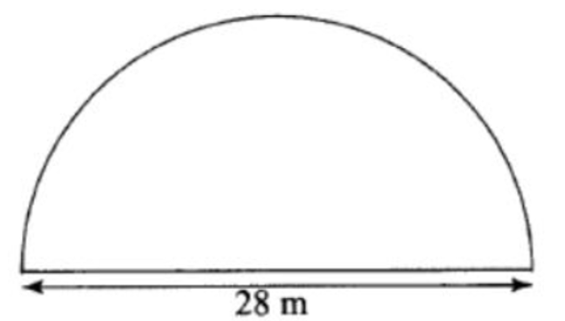
Figure 1
- 12
- 17
- 18
- 19

- Table 1 shows prices of food in Zaire hotel.
Table 1
 | Ugali | Rice | Chips
Nyama | 150 | 180 | 200
Samaki | 160 | 170 | 210
Kuku | 240 | 180 | 250
A team of eleven people took lunch in the hotel as follows: 4 people took Rice and Nyama; 3 people took chips and kuku; 2 people took Ugali and Samaki; and the rest took Ugali and Kuku. Find the total amount paid. (1 Mark)
- 1790
- 1950
- 2270
- 2250
- A man started painting a wall at 7.48 am. He had a lunch break of one hour forty minutes. If he finished the work at 3.28pm and was paid kshs.400 per hour for actual working hours, find how much he earned. (1 Mark)
- 2,800
- 2,400
- 3,200
- 2,666

SECTION B (40 MARKS)
Answer all the questions in this section.
- Draw the graph of a line $y=2x-3$ given that $-3≤x≤3.$ (4Marks)
- A patient is supposed to walk a distance of 2km in a mid-morning therapy session. He uses the hospitals corridors as the walking paths. The hospital corridors he uses are of the shape shown in figure 2 and the distance he walks in each corridor is indicated.
140M

60M
90M
A
B
C
D

Figure 2
He starts at point A and covers the entire corridors to and from until he covers the required distance. How many times will he come back to point A before covering the required distance? (4 Marks)
- A particular map shows a scale of 1:5000. Find the distance in metres of the road if it measures 8cm on the map. (3 Marks)
- A section of a walking path is 2m wide and 12m long. It is made from concrete 6cm thick. Find the volume of concrete, giving your answer in c𝑚³. (4 Marks)
- Table 2 shows height of girls in a class.
Table 2
Height in cm | Numbers of Girls
135-139 | 4
140-144 | 7
145-149 | 18
150-154 | 11
155-159 | 6
160-164 | 5
- Find the average height of the girls whose heights are 155 cm and above; (3 Marks)
- Find the number of girls whose heights are below 150 cm. (1 Mark)
- Work out $\frac{\left(18÷3\right)+\frac{1}{2}\left(-20+4\right)}{-4-6÷2}$ (3 Marks)
- A rectangle measures 20cm by 15cm. If each of the dimensions is increased by 2.5cm, find the percentage increase in area. (4Marks)
- Using a ruler and a pair of compasses only,
- Construct triangle ABC in which AB=5cm, BC=6cm and angle ABC=120⁰ ; (3Marks)
- Measure angle ACB. (1 Mark)
- Table 3 shows the number of items produced in a factory over a duration of two weeks.
Table 3
Day | Monday | Tuesday | Wednesday | Thursday | Friday | Saturday | Sunday
Week 1 | 18 | 21 | 21 | 24 | 29 | 20 | 21
Week 2 | 16 | 20 | 18 | 15 | 21 | 18 | 18
- Which week had higher production and by how much? (3 marks)
- Find the difference between the mean for the two weeks. (3 Marks)
- Figure 3 represents a flower garden. Find the area of the flower garden. Take π = $\frac{22}{7}.$
(4Marks)
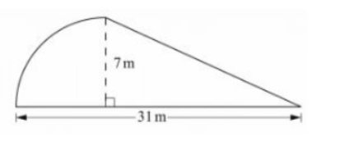
7m
Figure 3

THIS IS THE LAST PRINTED PAGE

