
THE KENYA NATIONAL EXAMINATIONS COUNCIL

Qualification Code : 041305T4BUS
Qualification : Business Management Level 5
Unit Code : BUS /OS/BM /CR /06/ 5/A
Unit of Competency : Coordinate Information Communications Technology (ICT) Functions

This paper consists of FIVE (5) printed pages.
The candidate should check the question paper to ascertain that all the
pages are printed as indicated and that no questions are missing.

INSTRUCTIONS TO THE CANDIDATE
PRACTICAL ASSESSMENT
- You are allocated 15 minutes to read through the instructions
- You are allocated three hours to perform the two tasks.
- The paper consists of Two tasks
- You are required to perform all tasks
- You are provided with the following resources for the tasks:
- Computer
- Windows 8 setup in CD
- Email software installed (Microsoft Outlook)
- Printer
- Printing papers
- Do not write on the question paper
- Marks for each question are indicated in the brackets [ ]
- The candidate should have an identification tag pinned at the back and front near the shoulders showing Candidate’s name and registration code.
TASK 1
The table below shows contacts of Board of Directors of a certain company prepared by a secretary. Use it to answer the questions that follow.
Full Name | Company | Job Title | Email
Mary Martin | Coke | Sales manager | mary@gmail.com
Ochieng Kamau | 2NK Technologies | Director | twonk@gmail.com
Mary Achieng | Happy Technologies | Director | Happytechnologies @gmail.com
Kyalo Musau | Musau Technologies | Secretary | muasu@gmail.com
Karen Ogombe | Ogombe Technologies | Director | ogombe@gmail.com
Nelly Fatuma | Nelly Technologies | Sales manager | nelly@gmail.com
Mary Wako | Google Technologies | CEO | google@gmail.com
Ngome Charo | Maggie Technologies | Director | ngomecharo@gmail.com
Martin Ochieng | Ochieng Technologies | Manager | Ochieng@gmail.com
Patrick John | Pattie Tech | Operations | Pattie@gmail.com
Sussie Wakesho | CIT | Administrator | sussie@gmail.com

- Open an email program and create contacts as shown in table above.
- Screen capture the address book created in (a) and paste it in a word processing program and save the email as Contacts in the CDACC ASSESSMENT TOOLS folder to print out later
- Open an email program and compose an email to contacts@contacts.com attaching all the contacts as business cards. Screen capture and paste it in word processor program and save it as Contacts_b in the CDACC ASSESSMENT TOOL Folder to print
- Insert the following addresses in the email created in (c) as follows
CC: muasyah@gmail.com , martinkamau@gmail.com, marynjeri@gmail.com
BCC: olouchjuma@gmail.com, stephenngome@gmail.com director@gmail.com
- Screen capture and save the task as Blindcarboncopy in CDACC ASSESSMENT TOOLS folder to print out later

- Create an email program and key in the following calendar meetings’ appointments as shown in table1. Screen capture the appointment window and paste it in a word document. Save the document as Appointments in CDACC ASSESSMENT folder to print out later. (5 marks)
Table 2
Time | Subject | Location | Remarks
8.00am – 9.00am | Lesson Plan Meeting | HOD -ICT office | Schemes of work and teaching materials required
10.00am – 10.30am | Break Time | Staffroom | Optional
11.00am – 11.30am | Lesson One | Module 3 class | Critical and Core business
12.00pm – 12.30 pm | Lesson 2 | Module 2 class | Critical and Core business
1.00pm – 1.30pm | Lunch Break | Cafeteria | Optional
2.00pm – 2.30pm | Games | Games Pitches | Critical and core business
3.00pm -4.30pm | Afternoon | Personal | Private
- Invite the attendees for your lunch break appointment as shown in table 2, Screen capture the meeting details and paste it in word document. Save it as Invites in the CDACC ASSESSMENT folder to print out later
- Print the documents Contacts, Contacts_b , Blindcarboncopy, Appointments

Task 2
Mr. Ochieng, who is the CEO of MPESA Technologies (K) has started his computer it has displayed the following message on the screen and has requested you to assist him.
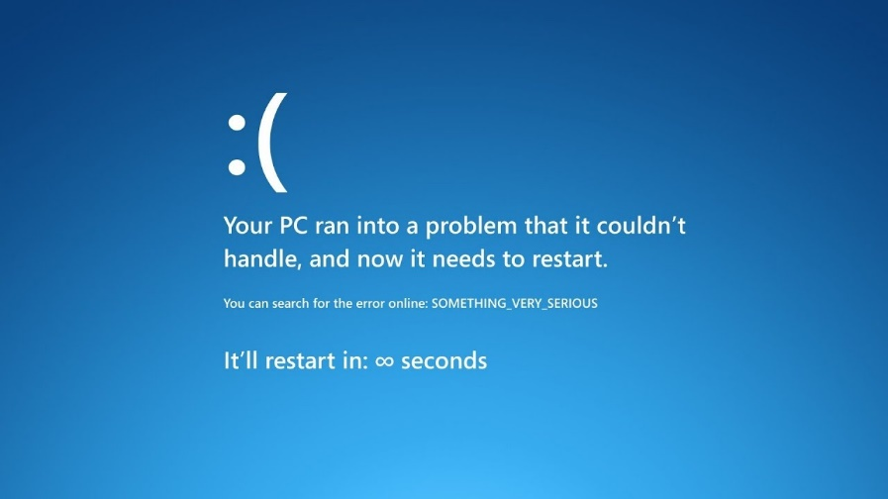

- Perform installation of operating system using windows 8 provided.

