061006T4ICT
ICT TECHNICIAN LEVEL 6
IT/OS/ICT/CR/11/6/A
DEVELOP MOBILE APPLICATION
Mar. /Apr. 2023

THE KENYA NATIONAL EXAMINATIONS COUNCIL

PRACTICAL ASSESSMENT

INSTRUCTIONS TO THE ASSESSOR
- You are required to mark the practical as the candidate performs the tasks.
- You are required to take video clips at critical points.
- Ensure the candidate has an identification tag pinned at the back and front near the shoulders showing Candidate’s name and registration code.

OBSERVATION CHECKLIST
Candidate’s name & Registration Code
Assessor’s name & Registration Code
Venue of Assessment
Date of assessment
Items to be evaluated: Please award marks as appropriate. Give a brief comment on your observation. | Marks available | Marks obtained | Comments
TASK 1: Design the App using Android studio
- Opened the xml file  (Award two mark or zero) | 2
- When to the text and wrote the code for adding 3 textview,2 textedit and Button and Assign ID to each component. Assign margin top, left, right for the location.  (Award max of fourteen marks) | 14
- Opened up the activity java file. (Award 2 marks or zero) | 2
- Declared few variables and the values entered in the Text Views can be read by using an id which we have set in the XML code above.  (Award 4 mark or zero) | 4
- Added the click listener to the Add button. (Award max of 6 marks) | 6
- When the Add button has been clicked, added the values and store it into the sum variable. (Award max of 4 marks) | 4
- Showed the output in the result text view and set the sum in the textview.  (Award max of 6 marks) | 6
TASK 2:
Installed the app in emulator  (Award 4 marks or zero) | 4
Run the App in emulator  (Award a max of two marks) | 2
Screenshot the interface of the app and printed (Award a maximum of six marks) | 6
Total | 50
ASSESSMENT OUTCOME
The candidate was found to be:
Competent Not yet competent

(Please tick as appropriate)
(The candidate is competent if the candidate obtains at least 50%)
Feedback from candidate:
Feedback to candidate:
Candidate’s Signature Date
------------------------------ -----------------------------
Assessor’s Signature Date
------------------------------ -----------------------------

THE PRACTICAL

Android | App to Add Two Numbers
Below are the steps for Creating a Simple Android Application to Add Two Numbers
- STEP-1: First of all, go to the xml file
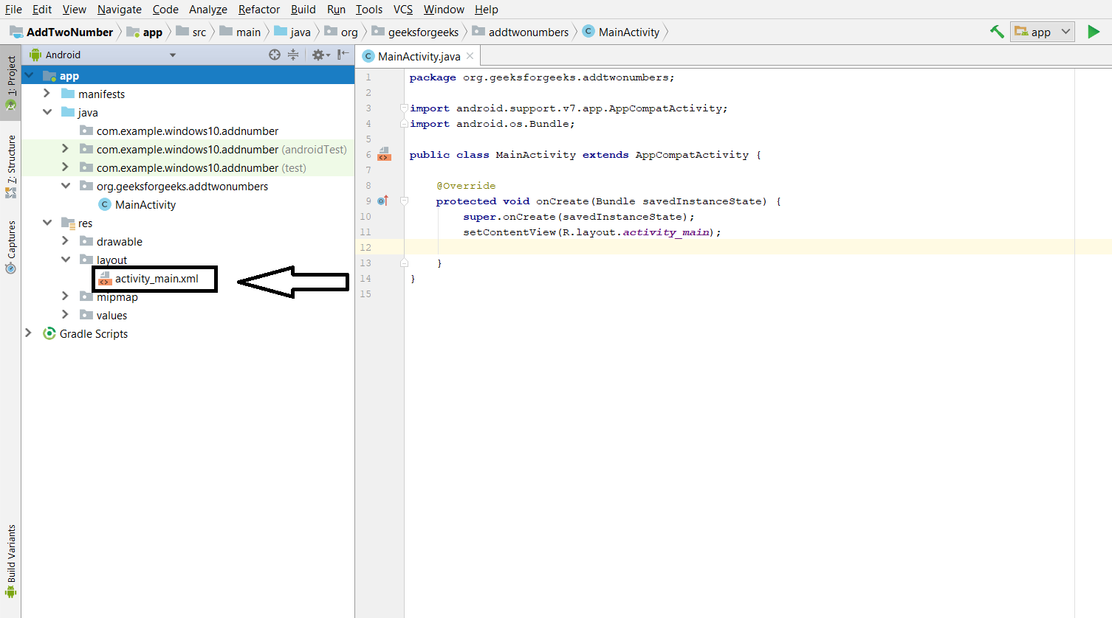
- STEP-2: Now go to the text and write the code for adding 3 textview,2 textedit and Button and Assign ID to each component. Assign margin top, left, right for the location.
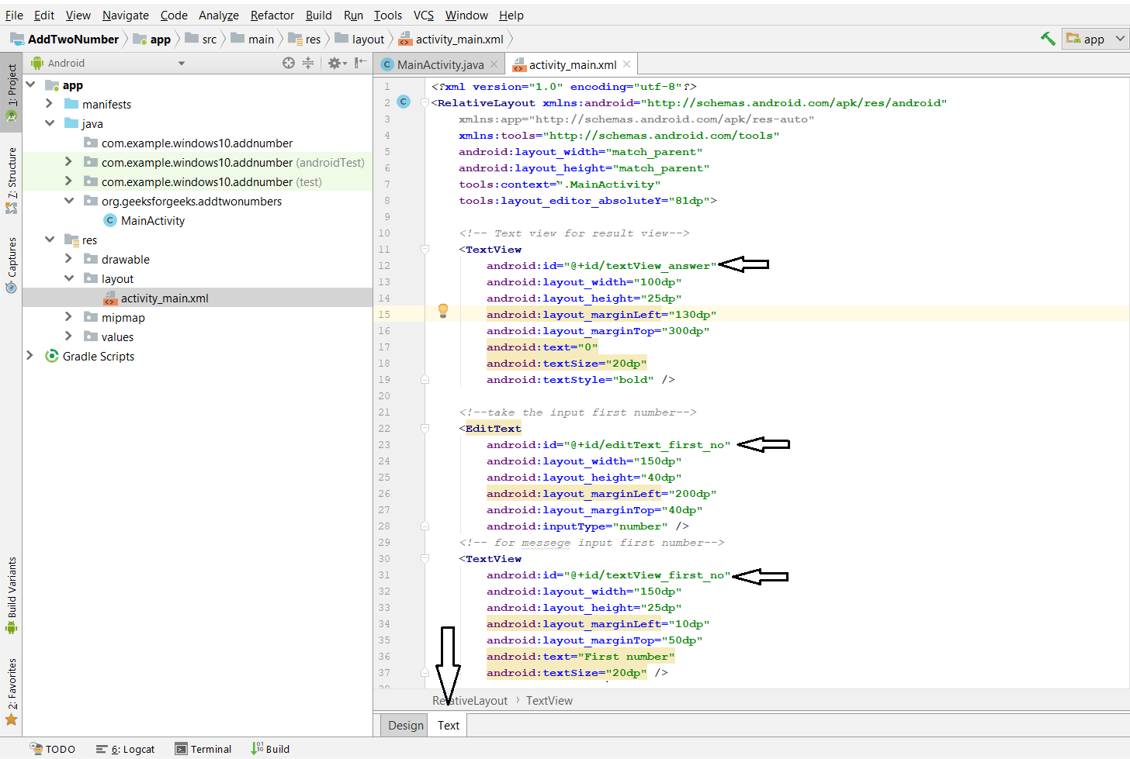
- STEP-3: Now, open up the activity java file.
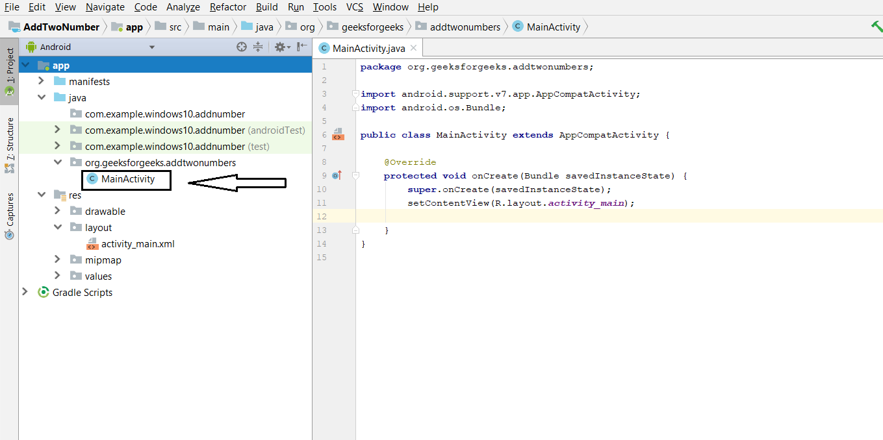
- STEP-4: Declare few variables and the values entered in the Text Views can be read by using an id which we have set in the XML code above.
- STEP-5: Add the click listener to the Add button.
- STEP-6: When the Add button has been clicked, add the values and store it into the sum variable.
- STEP-7: To show the output in the result text view, set the sum in the textview.
Complete code of layout xml file and java file is given below.
- activity_main.xml
- MainActivity.java
// Each new activity has its own layout and Java files,
// here we build the logic for adding two number

package org.geeksforgeeks.addtwonumbers;

import android.support.v7.app.AppCompatActivity;
import android.os.Bundle;
import android.view.View;
import android.widget.Button;
import android.widget.EditText;
import android.widget.TextView;

public class MainActivity extends AppCompatActivity {

// define the global variable

// variable number1, number2 for input input number
// Add_button, result textView

EditText number1;
EditText number2;
Button Add_button;
TextView result;
int ans=0;

@Override
protected void onCreate(Bundle savedInstanceState) {
super.onCreate(savedInstanceState);
setContentView(R.layout.activity_main);

// by ID we can use each component which id is assign in xml file
number1=(EditText) findViewById(R.id.editText_first_no);
number2=(EditText) findViewById(R.id.editText_second_no);
Add_button=(Button) findViewById(R.id.add_button);
result = (TextView) findViewById(R.id.textView_answer);

// Add_button add clicklistener
Add_button.setOnClickListener(new View.OnClickListener() {

public void onClick(View v) {

// num1 or num2 double type
// get data which is in edittext, convert it to string
// using parse Double convert it to Double type
double num1 = Double.parseDouble(number1.getText().toString());
double num2 = Double.parseDouble(number2.getText().toString());
// add both number and store it to sum
double sum = num1 + num2;
// set it ot result textview
result.setText(Double.toString(sum));
}
});
}
}
After Complete layout xml file it will be shown as given below
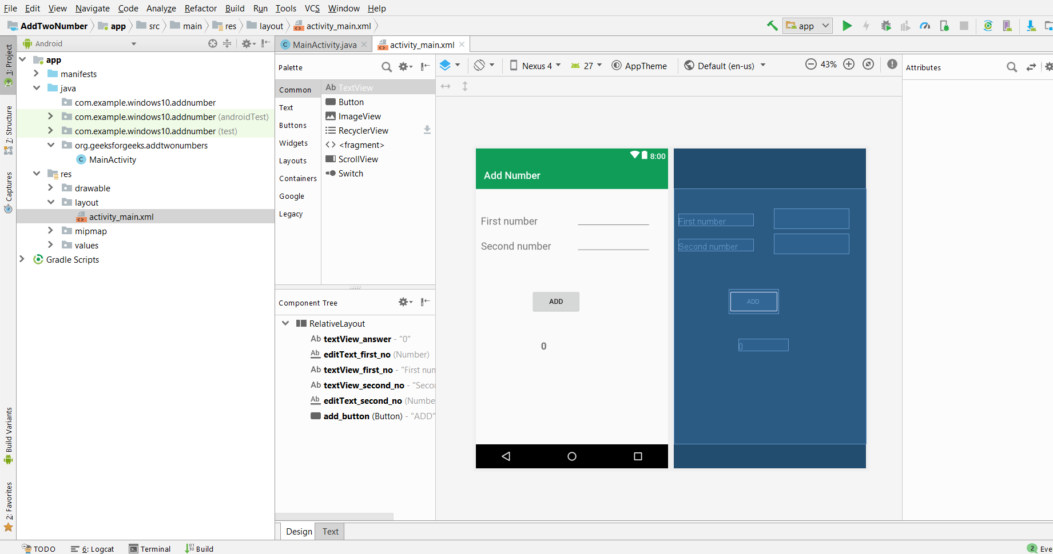
Output:
