QUALIFICATION CODE : 102106T4COH
QUALIFICATION : ASSISTANT COMMUNITY HEALTH OFFICER LEVEL 6
UNIT CODE : HE/OS/CH/CR/03/6/A
UNIT OF COMPETENCY : CONDUCT COMMUNITY HEALTH DIAGNOSIS AND
PARTNERSHIPS
March/April 2023
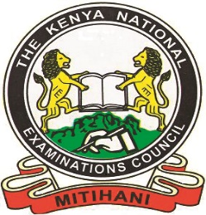

THE KENYA NATIONAL EXAMINATIONS COUNCIL
PRACTICAL ASSESSMENT
1 hour
INSTRUCTIONS TO CANDIDATE:
- You are required to give a presentation on the process of Community Health Diagnosis.
- The assessor shall be required to take photos/video record during the assessment.

This paper consists of TWO (2) printed pages.

Candidates should check the question paper to ascertain that both pages are printed as indicated and that no questions are missing.

© 2023 Kenya National Examinations Council
You are provided with the following resources
- 5 Simulated community members
- 2 marker pens
- 3 flip charts or manilla papers
- White board
- 1 Masking tape
- 2 foolscaps
- 5 chairs
- 1 pen

After community health diagnosis was carried out in your community, immunization defaulting and mixed feeding for children under six months of age was prioritized.
Task
With participation from the community members, develop an action plan for the implementation of the suggested interventions.

