Demonstrate Digital Literacy Level 6
3 Hours
March/April 2023


THE KENYA NATIONAL EXAMINATIONS COUNCIL
WRITTEN ASSESSMENT

Time: 3 hours

INSTRUCTIONS TO CANDIDATE
This paper consists of TWO sections A and B.
Answer ALL questions in sections A and any THREE questions in section B in the answer booklet provided.
Marks for each question are indicated in brackets.
Do not write on this question paper.
Answer the questions in English.

This paper consists of four (4) printed pages.

Candidate should check the question paper to ascertain that all the pages are printed as indicated and that no questions are missing.

SECTION A (40 MARKS)
Answer ALL questions in this section
- With the aid of examples distinguish between computer software and computer hardware as used in digital literacy. (4 Marks)
- Identify four types of data that can be entered in a spreadsheet. (4 Marks)
- Outline three services offered by internet. (3 Marks)
- State three disadvantages of using of internet to perform daily activities. (3 Marks)
- Cyber security has become a big issue whenever one is online. Highlight two mitigation measures against online security threats. (2 Marks)
- Information communication technology is a fast-growing field. You have been asked by your manager about emerging trends and issues in this field. Name four emerging trends. (4 Marks)
- Define the term mail merging and list three files to be created during this process. (5 Marks)
- Cell referencing refers to how cell(s) are identified in a worksheet. Differentiate between relative cell referencing and absolute cell referencing. (3 Marks)
- Differentiate between a word processor and word processing. (2 Marks)
- State three measures against physical computer theft. (3 Marks)
- Differentiate between the copy command and the cut command as applied in word processing. (2 Marks)
- State the meaning of the following computer crimes:
  - Fraud (1 Mark)
  - Hacking (1 Mark)
- Identify the parts numbered 1- 3 on the web browser in Figure 1. (3 Marks)
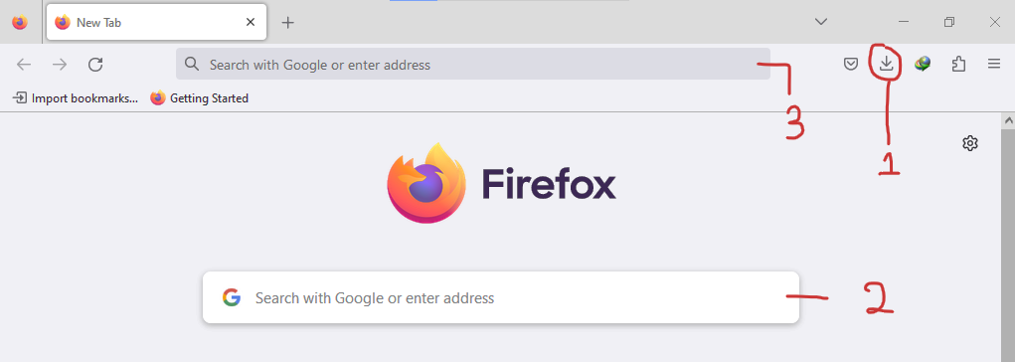
Figure 1

SECTION B (60 MARKS)
Answer any THREE questions in this section
- a) Manyatta NG-CDF deals with a lot of private data from bursary applicants in the constituency. Explain three principles of data security they must observe in order to safeguard the data. (6 Marks)
- Explain four types of computer malware. (8 Marks)
- Explain three editing tools that are found in a Word Processing software. (6 Marks)
- a) You have been writing a report using a word processor. Describe the steps you would follow to save the report in your computer. (5 Marks)
- Describe three main alignment styles used in word processing. (6 Marks)
- Explain two main objects found in Microsoft Access. (4 Marks)
- Outline five factors to consider when purchasing a software. (5 Marks)
- a) Computers have a widespread use in people’s lives on a day-to-day basis. Discuss five such areas where computers are used. (10 Marks)
- Computer viruses can affect the performance of the computer. Describe three control measures against viruses. (6 Marks)
- The laws governing ICT in a country and globally are crucial in protecting the rights of citizens. Highlight four challenges addressed in the Kenyan national ICT policy of 2019. (4 Marks)
- a) Use the information provided in figure 2 to answer the questions;
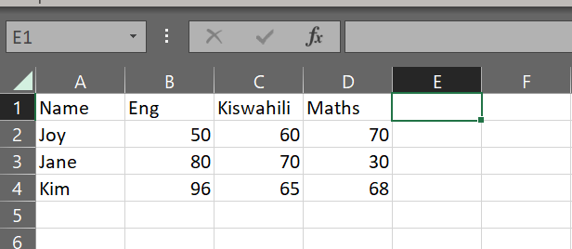
Figure 2

- Write a formula to calculate the total marks for Joy. (3 Marks)
- Write a formula to add the Eng and Maths mark for Jane. (3 Marks)
- Write a formula to calculate the mean mark for Kim. (3 Marks)
- Write a formula indicate the highest mark in Eng. (3 Marks)
- Write a formula to indicate the lowest mark in Kiswahili. (3 Marks)
- In reference to (a) above, Hellen wanted to email the completed worksheet to her trainer for marking. Explain the procedure she would use in order to submit the work. (5 marks)

THIS IS THE LAST PRINTED PAGE

