Demonstrate Digital Literacy Level 4
2 Hours
March/April 2023


THE KENYA NATIONAL EXAMINATIONS COUNCIL
WRITTEN ASSESSMENT

Time: 2 Hours

INSTRUCTIONS TO CANDIDATE
This paper consists of TWO sections A and B.
Answer ALL questions in sections A and B in the answer booklet provided.
Marks for each question are indicated in brackets.
Do not write on this question paper.
Answer the questions in English.

This paper consists of five (5) printed pages.

Candidate should check the question paper to ascertain that all the pages are printed as indicated and that no questions are missing.

SECTION A (10 MARKS)
Answer all questions in this section. Each question carries one mark.
- ________________ displays a window at its previous size.
- Restore Down Button
- Restore Up Button
- Maximize Button
- Minimize Button
- HTTP stands for______________.
- Hypertext Trade Protocol
- Hypertext Transmission Protocol
- Hypertext Transfer Protocol
- Hypertext Text Protocol
- Which software can damage a computer system?
- Microsoft Word
- Microsoft Excel
- Trojan Horse
- Kaspersky
- A Windows Operating system uses WIMP feature. What does letter M stand for?
- Memes
- Messages
- Memory
- Menus

- Refer to figure 1. In what cell number would a new blank cell be inserted?
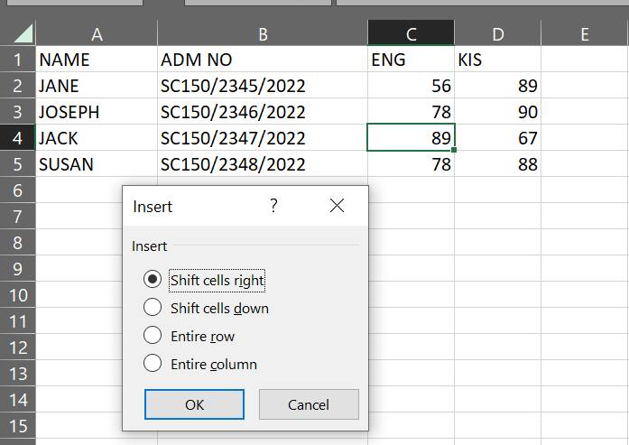
Figure 1
- C6
- 4C
- C5
- C4
- The Kenya Data Protection Act of 2019 protect against the following except?
- Your computer from being hacked.
- Your personal data stored on the computer being stolen.
- Theft of copyright materials on your computer.
- Your computer being stolen.
- Which one of the following option allows recipients of an email to see a list of other recipients who received a copy of the same message?
- Bcc
- Cc
- Copy to
- Copy
- A____________is the largest type of computer based on size.
- Mega Computer
- Super Computer
- Desktop Computer
- Mainframe Computer
- Which one of the following passwords is a smart password?
- 1234567
- Abc1234
- Cba.1234
- Abcdefgh
- Which one of the following type of computer crime describes actions in which the computer is used only to further a criminal end?
- Hacking
- Fraud
- Cracking
- Theft
SECTION B (40 MARKS)
Answer all questions in this section.
- a) Outline three advantages of using Microsoft Word over taking notes using pen and paper. (3 Marks)
- When a picture is inserted into a Microsoft Word document and there are portions of it that should be removed. State the picture formatting command that would be the most appropriate to use. (1 Mark)
- Name three examples of a computer system hardware. (3 Marks)
- Outline three services offered by the internet. (3 Marks)
- Explain the meaning of a spam as found in e-mails. (2 Marks)
- When using e-mails;
- Which button would be clicked to re-send the message to a third person? (1 Mark)
- _________ button will be clicked to send feedback to the original sender as well as to all the people in the mailing list. (1 Mark)
- Which is the name given to the file that is uploaded in an e-mail? (1 Mark)
- With respect to computer networks;
- A worldwide connection of computer networks that allows people to communicate and exchange information is called________? (1 Mark)
- Which software is used to access resources on the internet? (1 Mark)
- What is the full meaning of URL? (1 Mark)
- Name three types of data you can enter into worksheet cells. (3 Marks)
- Write the calculation functions that can be used for carrying out following operations:
- To calculate total marks of a student if his marks in five subjects are given in five different cells. (1Mark)
- To calculate mean sales made by salesman of a company. (1 Mark)
- To find out the marks of a top scorer in a class, if marks of all the students are available. (1Mark)
- To find out minimum quoted rate from various quotations available. (1Mark)
- Describe three activities that can be performed to prevent spread of computer viruses. (3 Marks)
- Explain two types of computer output devices. (4 Marks)
- a) Name the system software that manages computer hardware and software resources and provides common services for computer programs. (1Mark)
- State one example of a software that can be used to edit photos. (1Marks)
- Name one computer application software that performs the task of composing, editing, formatting, and printing of documents. (1Mark)
- Identify one computer software for calculating, analysing and storage of data in tabular form. (1Mark)
- a) Identify the menu tab in Microsoft Word that has font related options. (1Mark)
- Name the menu tab in Microsoft Word that has mail merge related options. (1Mark)
- Name the menu tab in Microsoft Word that has table related options. (1Mark)
- Name the menu tab in MS-Word has watermark related options. (1Mark)

THIS IS THE LAST PRINTED PAGE

